**Brian Booth Test Cricketer  
  
by Graham McLennan\***

[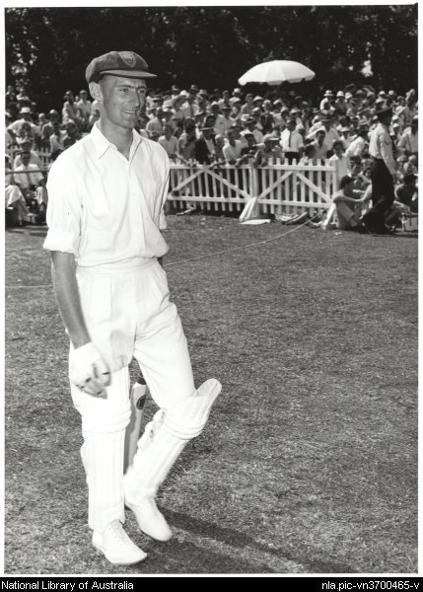](http://www.google.com.au/url?sa=i&rct=j&q=&esrc=s&source=images&cd=&cad=rja&uact=8&ved=0CAcQjRw&url=http%3A%2F%2Fnla.gov.au%2Fnla.pic-vn3700465&ei=6l8eVcjpE87f8AWx8oGYBQ&bvm=bv.89947451,d.dGc&psig=AFQjCNGxdY3Z6cj-S4Z0N7k57W-gTzZHog&ust=1428140319974382)

Brian Booth represented Australia in two codes of sports, in 29 tests in cricket and at the 1956 Olympics in hockey.

During his cricket career he captained the Australian several times as well as being vice captain.   
During this time his Christian faith was paramount writing two books with Paul White, Booth to Bat with a foreword by Sir Donald Bradman and Cricket and Christianity to "help you live with a straighter bat and to maintain a better line and length".   
He also wrote Hockey Fundamentals and  could have also represented Australia in athletics, his times were so good especially the 400 metres in 50.8 seconds without any coaching!  
  
Brian Booth was a devout Christian and an Anglican lay-preacher, described by one journalist as "if a prize were offered for fairplaymanship among Australia's post-war cricketers Brian Booth ought to win it hands down".  
  
To read more about Brian Booth, his cricketing career and his faith please go to <http://en.wikipedia.org/wiki/Brian_Booth>  
  
*Whilst not a Christian at the time he was my physical education instructor at Hurlstone Agricultural High School, on one occasion taking me in his VW to the Sydney combined high schools swimming championships at North Sydney.