Significant Christian Sites in Sydney
Dr Graham McLennan February 2020
If you have difficulty coming to Sydney or can’t find a location Google Street View may help.
On January I8, 1788, the first Governor of New South Wales, Captain Arthur Phillip, R.N., sailed into Botany Bay and was followed within the next two days by the whole of the first fleet.
The First Fleet was the 11 ships that departed from Portsmouth, England, on 13 May 1787 to found the penal colony that became the first European settlement in Australia. The Fleet consisted of two Royal Navy vessels, three store ships and six convict transports, carrying between 1,000 and 1,500 convicts, marines, seamen, civil officers and free people (accounts differ on the numbers), and a large quantity of stores. From England, the Fleet sailed southwest to Rio de Janeiro, then east to Cape Town and via the Great Southern Ocean to Botany Bay, arriving over the period of 18 to 20 January 1788, taking 250 to 252 days from departure to final arrival.
Dissatisfied with the bay as a harbour, and to adjoining land as a place for the settlement, he decided to explore Port Jackson and Broken Bay. On the morning of the 21st, accompanied by Captain Hunter, Captain Collins, a lieutenant, and a small party of marines, he proceeded in three ships' boats and entered Port Jackson. Turning first to the southern shore, he landed on the pretty beach known today as Camp Cove.
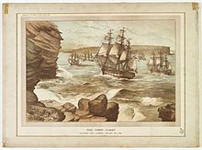
The First Fleet entering Port Jackson on 26 January 1788 by Edmund Le Bihan
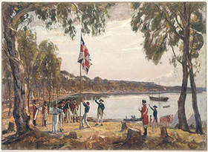
Governor Arthur Phillip raising the flag. Read about the sovereignty of God delaying settlement with Governor Phillip’s instructions as well as the faith of some early navigators. Read more about Governor Phillip here Early history of Sydney settlement see here
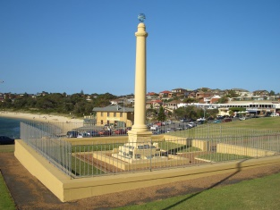
Monument at La Perouse
The La Perouse expedition arrived off Botany Bay on 24 January 1788, just as Captain Arthur Phillip was attempting to move the colony from there to Sydney Cove in Port Jackson. The First Fleet was unable to leave until 26 January because of a tremendous gale, which also prevented Lapérouse's ships from entering Botany Bay.
Apparently two Masses were said on board either on Saturday, 26th January, the Feast of St. Polycarp or Sexagesima, Sunday 27th January, 1788 in accordance with the duties of chaplains in the French navy of the ancien régime as specified in a royal ordonnance of 1765.
Read more here
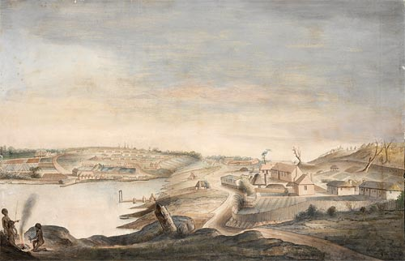Sydney Cove 1788

Richard Johnson Square, Bligh and Hunter Streets, Sydney.
First Church, used as a School. Please read a speech here on his education of the children, duties and other responsibilities as well as his vegetable garden and farming at his 100 acre Canterbury farm as the first orchardist and wheat grower. Please view by scrolling down to this short video on the Rev Richard Johnson here
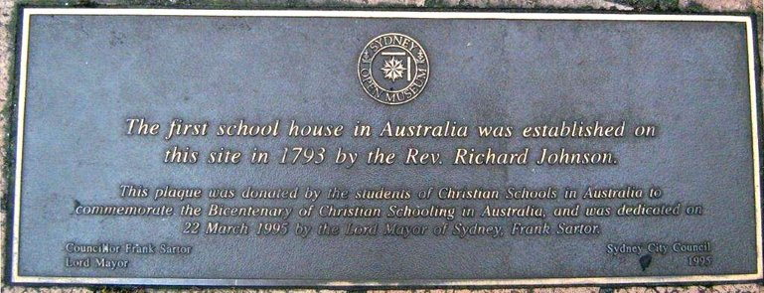
Lands Building
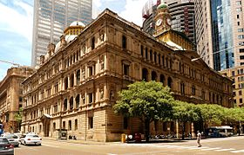
22-33 Bridge St
On the Bridge Street facade you will find Matthew Flinders, Hamilton Hume, Sir Joseph Banks, Charles Sturt, Arthur Phillip, William Wills, George Bass, Robert O’Hara Burke, William Hovell, John Oxley, Ludwig Leichhardt, and Sir Thomas Mitchell. On the Bent Street facade are Allan Cunningham, Sir John Robertson, Gregory Blaxland, Sir William Charles Wentworth, William Lawson, and James Farnell. On the Gresham, Street facade are, Sir Henry Parkes, Sir James Martin, Daniel H Deniehy, and Sir George Grey. On the Loftus Street facade, stand John Macdouall Stuart and James Meehan.
Read about some of Christian explorers here and early governors, as well as early pioneers.
Opposite the Lands Building is a stone monument where distances where measured from in the New Colony begun by Governor Macquarie.
Next to the this is a water fountain. Amongst the many public Christian symbols in Australia are these remarkable drinking fountains in Sydney with the inscription from John 4:13-14
"Whosoever drinketh of this water shall thirst again; But whosoever drinketh of the water that I shall give him shall never thirst."
Picture below: Fountain in Macquarie Place corner Bridge and Loftus Streets, South of Circular Quay
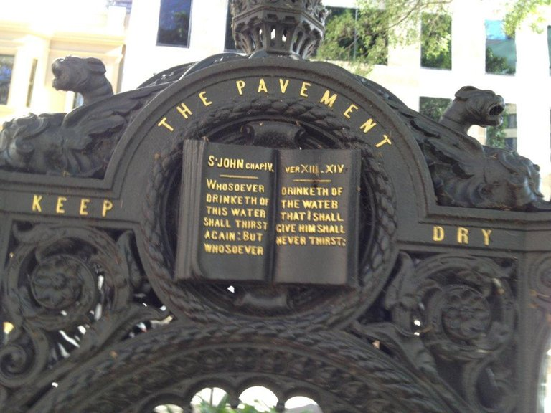
A similar fountain is on the corner of Oxford and Riley Streets Sydney.
Read more of the Sydney fountains.
Bennelong Point - Opera House.

Bennelong an Aboriginal after his wife Borangaroo (place on western side of Harbour Bridge) died married Abaroo (Boorong) who was raised for 18 months in Richard & Mary Johnsons home where she was taught some basic English and Scripture.
Bennelong & Abaroo had a son born about 1803 who became a Christian in his youth possibly becoming the first Indigenous evangelist. Abaroo (Boorong) is buried alongside Bennelong's Grave at 25 Watson Street Putney near the Paramatta River.
Sydney home bought by NSW government for $2.9m to be transformed into memorial to honour Eora nation elder.

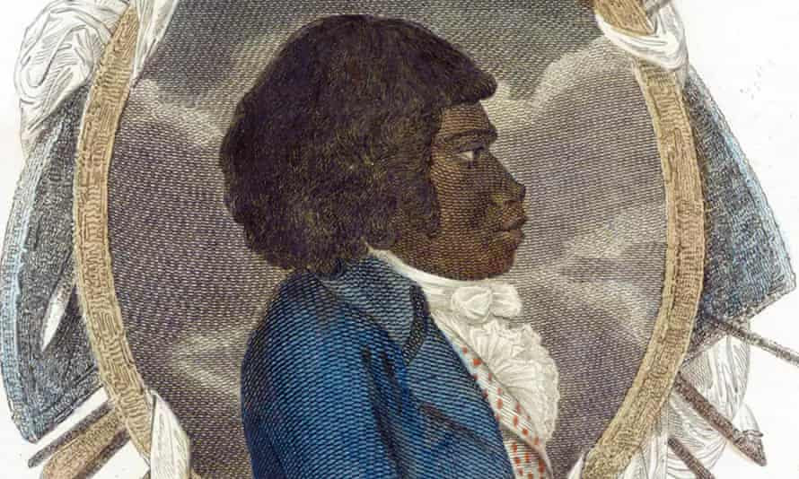

The Sydney grave of Indigenous warrior and a peacemaker Woollarawarre Bennelong will be turned into a public memorial site. Photograph: Alamy Stock Photo

For further information about the interaction of Christians and Indigenous people please read One Blood by John Harris at the end.

William Bligh Statue at Circular Quay near Cadman’s Cottage towards Overseas Terminal. Read what’s on the back. View this video on the faith of William Bligh

The Rocks: St Phillips Church history The original church was built by orders of the colony's first chaplain, the Reverend Richard Johnson, using convict labour in June 1793. The wattle and daub construction church was later burnt down by convicts in 1798.^{[3]} A second stone church operated on the current site of Lang Park from 1810 to 1856. It was made from poor materials and gained a reputation as "the ugliest church in Christendom". This second church had a 150-feet high, round clock tower.^{[4]} The Church has Johnson’s Bible and other items.

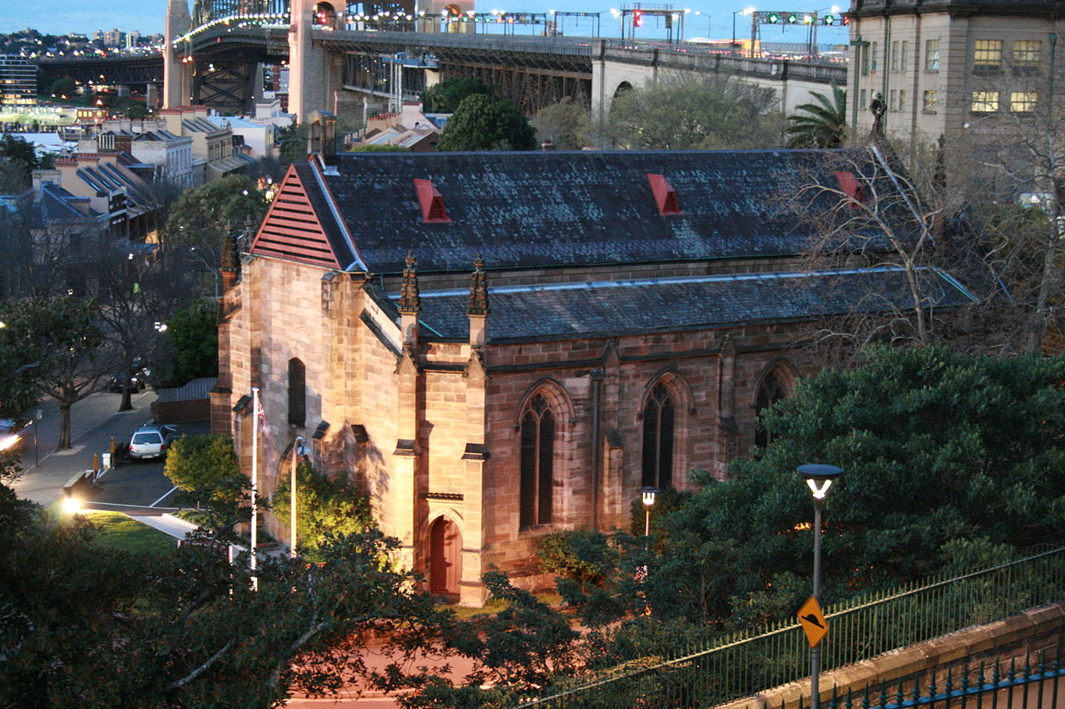

The Garrison Church (above) is the first military church built in colonial Australia.^{[2]} It continues as an active Anglican church, and since 1 November 2013 has operated in a joint parish with St Philip's Church,^{[3]} part of the Diocese of Sydney.
Dawes Point named after Lt William Dawes a Christian of some note. Please refer to the Australian Dictionary of Biography http://adb.anu.edu.au/biography/dawes-william-1968
Scots Church Sydney Corner of Margaret and York Streets, Sydney. Directly across from Wynyard Park.
The Cenotaph Martin Place. ANZAC Day begun by Chaplains returning from Gallipoli. Learn about the origins of Remembrance and ANZAC Day here by scrolling down the page
George Street:
Town Hall Revival meetings - 1909 Hungry for God's Word
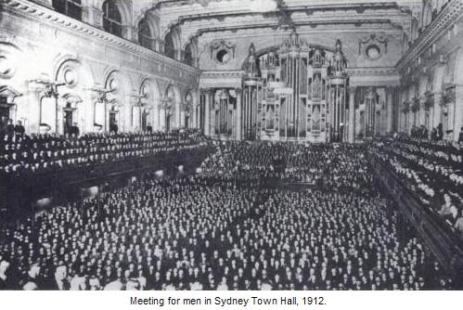
The Man from George Street - Frank Jenner two videos here
St Andrew’s Cathedral
Central Baptist Church 619 George St
Macquarie Street, named after Governor Macquarie. Please read about early Governors here
NSW Parliament. NSW Legislative Council originally a Church
St Stephen's Presbyterian (now UC) Church opposite entrance to NSW Parliament. Originally on the site of the State Library.
The “Rum” Sydney Hospital Museum Originally called the Rum Hospital because convicts were paid to import rum for re-sale, Sydney Hospital was founded as a convict hospital in 1788 and was the first building on Macquarie St. It was completed in 1894 and the two outer wings remain today in the form of The Mint and NSW Parliament House.
(Also see Royal Prince Alfred Hospital (built 1882) Museum where you can see one of Florence Nightingale’s letters to the nurses.)
St Mary’s Cathedral St Mary’s Road
St James Church
Every city has places that quietly yet powerfully uplift us, enabling us to recalibrate, rebalance, move along. When we spend time in our city’s sacred places we help heal our fractured selves. We’re more awake to the world around us – to Nature, to others, to what makes our souls sing.
If you’re in need of a little inspiration and solace, head to the Children’s Chapel , in the crypt of St James Church, right in the city centre at 173 King St, close to Hyde Park. The art in this tiny chapel was designed to look like an illuminated book of old, is filled with angels and children, with Sydney Harbour in the 1920s as a backdrop.
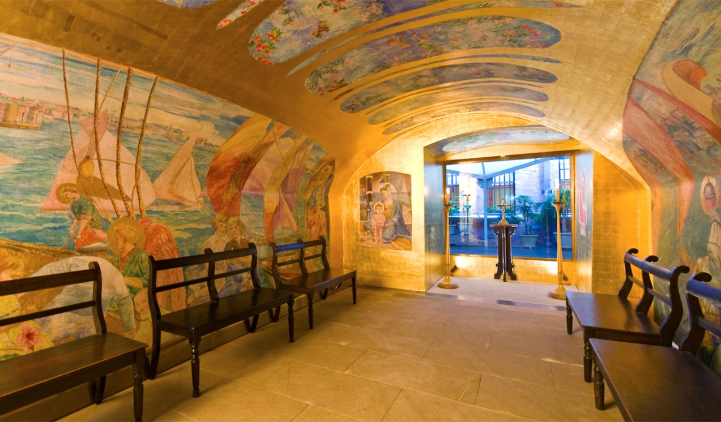

Salvation Army Congress Hall 140 Elizabeth Street
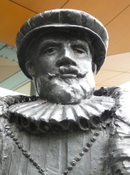
De Quiros Statue. Chalmers Street Surry Hills near Central Station. Learn more about De Quiros who named the lands to the South of Vanuatu Southland of the Holy Spirit.
Federation Pavilion, Centennial Park
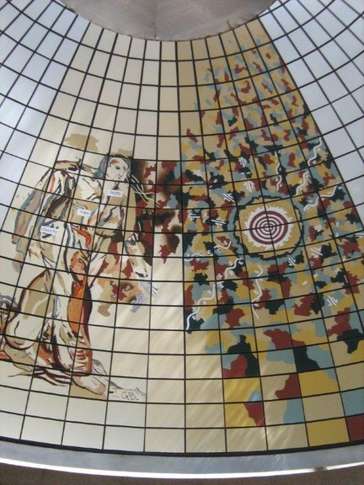
Pavilion erected in 1988 which contains the 1901 monument of the Federation of the six states.
The picture of the man contains the words: Faith, Hope & Charity - near tie, right chest & hip.
See the video of Federation Day 1 January 1901 in http://www.chr.org.au/multimedia.html
Elizabeth Farm- Elizabeth Macarthur 70 Alice Street Rosehill
Parramatta: Samuel Marsden (1765-1838), chaplain, missionary and farmer lived in Parramatta brought the Gospel to New Zealand Read book here.
Samuel Marsden's prophetic words about NSW:
" I can say this that I do not eat the bread of idleness. It is my opinion that God will
ere long visit New South Wales with his heavenly grace. Out of these stones he will
raise up children unto Abraham. There has not been any shaking yet among the dry
bones, but the Son of Man is commanded to prophecy and I hope by and by the
Lord will command the wind to blow. Stir up thy strength 0 God & come amongst us."
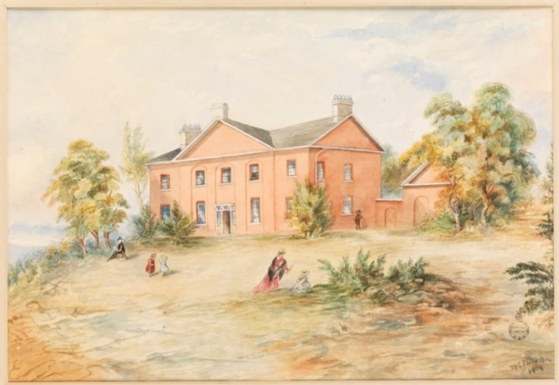
Marsden’s St John’s Parsonage, Parramatta, was Francis Greenway’s first major work as New South Wales, Acting Civil Architect. It is also the earliest documented house designed in the colony by a trained architect.
Parramatta Orphan School.
The three story building, the first of the new colony still remains standing to this day. It was commissioned by a Governor Lachlan Macquarie who showed Christian Faith in his daily life and felt something should be done for the orphan children of Parramatta. The building survives to this day as an example of early government Christian education that was started not as secular but Christian in its emphasis. See more here by scrolling down.
The first Sunday School began in Australia at Rowland Hassal’s home at the corner of George & Charles Streets Parramatta –now a Skyscraper!
Please read this booklet explaining the origins of the Sunday School movement both in England and here in Australia.

Some other places:

Schools:

Australia's Oldest Standing School and Church Building -1809 - Ebenezer Church
This video gives a short concise history of the founding of one of Australia's earliest Christian Schools. The Church is Australia's oldest standing and can be visited at Ebenezer, near Windsor, at the foothills of the Blue Mountains in Western Sydney. It remains to this day as a testament to those early Christian pioneers that settled the area in 1803 that established a Bible Based School for the Christian Education of their children. See a short video here and scrolling down.
The King's School Parramatta is Australia's oldest independent school and perhaps its best known. Founded in 1831 by command of King William IV of England, King's was established as a boys' school that would provide Australia with its next generation of leaders.
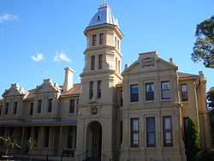
The Presbyterian Ladies' College was opened 30 January 1888, with 39 girls. It was modelled on the great English Public Schools,^{[20]} and was the first school to be established by the Presbyterian Church of New South Wales.
Some other places of worship in Sydney including other faiths such as the Jewish Synagogue with Trip Advisor.
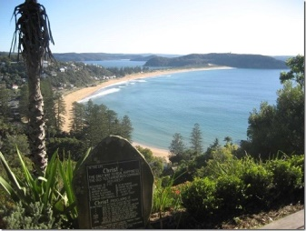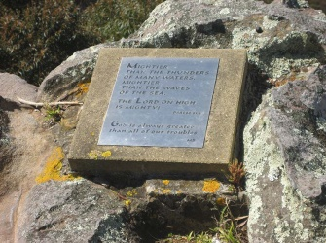
The Bible Garden at Palm Beach
Governor Phillip's Instructions
He was to enforce a due observance of religion and good order among the inhabitants, and take such steps for the due celebration of public worship as circumstances would permit. In the first draft of these instructions he was to grant full liberty of conscience, and the free exercise of all modes of religious worship not prohibited by law, provided his charges were content with a quiet and peaceable enjoyment of the same, not giving offence or scandal to government; he was to cause the laws against blasphemy, profaneness, adultery, fornication, polygamy, incest, profanation of the Lord's Day, swearing and drunkenness to be rigorously executed. He was not to admit to the office of justice of the peace any person whose ill-fame or conversation might occasion scandal; he was to take care that the Book of Common Prayer as by law established be read each Sunday and Holy Day, and that the Blessed Sacrament be administered according to the rites of the Church of England. Because of the great disproportion of female to male convicts, he was to take on board at any of the islands any women who might be disposed to come, taking care not to make use of any compulsive measures or fallacious pretences. He was to emancipate from their servitude any of the convicts who should, from their good conduct and a disposition to industry, be deserving of favour, and to grant them land, victual them for twelve months and equip them with tools, grain, and such cattle, sheep and hogs as might be proper, and could be spared. As the military officers and others might be disposed to cultivate the land, he was to afford them every encouragement.

Mariners Church 100 George St near Quay. 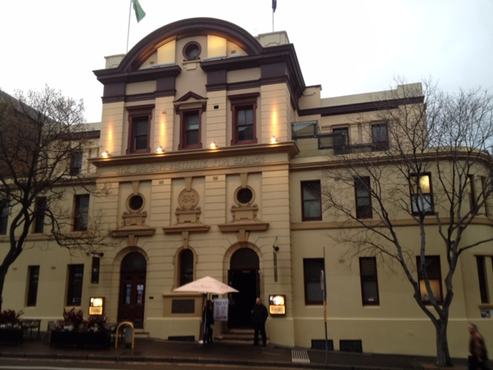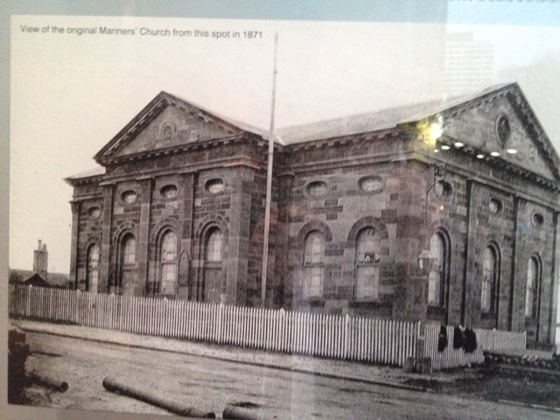

Revivals in the Sydney District and throughout Australia
Read Robert Evan’s Classic book on revivals here scrolling down to
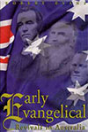
Early Evangelical Revivals in Australia
By Robert Evans Download: which includes places near Sydney including Parramatta, Windsor, Lower Hawkesbury and along the Nepean River from Penrith to Picton.
1. Early Revivals in New South Wales to 1858 P1
2. The 1859 Revival in New South Wales P24
1. "California" Taylor's Visit to New South Wales P38
2. Revivals in New South Wales. 1862 to 1876 P57
3. Revivals in New South Wales. 1877 to 1879. P93
Learn more by clicking here on our early missionaries such as Richard Johnson, Samuel Marsden, Rowland Hassall, John Watsford and Lancelot Threlkeld
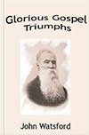
Glorious Gospel Triumphs by John Watsford Download:
200 Years of Aboriginal Encounter With Christianity: A Story of Hope by John Harris

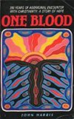
Download here
Also see Stories of Indigenous People here

