**A Hunger for God’s Word 1909**

**Revival in Australia, Part Three**

**By Jason Harris**

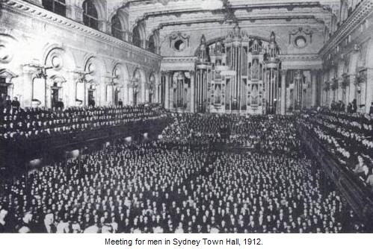

**...in Sydney, the Town Hall was not large enough to contain the crowds that came to hear the preaching. But once again God worked and many lives were changed and many souls were converted through the ministry of the word in Sydney. Though Chapman was the leading preacher, he brought with him a whole team of workers from Canada, Ireland, Scotland, England, and America. These, in conjunction with dozens of Australian pastors and evangelists, formed a team that preached and ministered systematically in a broad range of ways and places in each city where they ministered.**

**On the last Sunday of the Sydney Mission, the throngs were so great that the police, fearing accidents among the waiting thousands, ordered the doors to be opened at five o’clock. Word was sent to the hotel where Dr. Chapman and the Alexanders and others of the party were staying, to come at once to the Town Hall. They hurried over and began the meeting at half-past five. An hour later, by arrangement with the police outside, certain doors were opened for the attenders of the first meeting to pass out, while at the other end of the building the waiting crowds poured in to fill it once more for a second service. (*Romance*, 160)**

**The Chapman-Alexander campaign lasted for four months, as in each place where they went the believers were strengthened, the word was proclaimed, and sinners were convicted. As I study these missions and read the stories, I cannot help but pray “God, these people hungered for your word. Give us that same hunger. Do it again, Lord. Please. Do it again.”**

[**Read more**](http://teaminfocus.com.au/a-hunger-for-god%E2%80%99s-word/)