Turning the Tide in Prayer
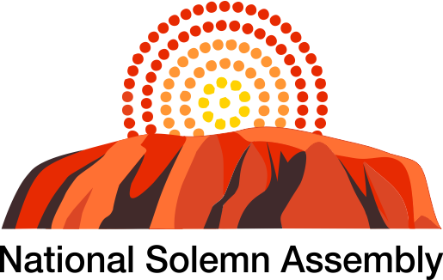
26-27 September 2020
Reflections on the National Solemn Assembly
By Dr Graham McLennan

“If my people, who are called by my name, will humble themselves and pray and seek my face and turn from their wicked ways, then I will hear from heaven, and I will forgive their sin and will heal their land.” 2 Chronicles 7:14
People of Australia, joined together to seek God's face for the healing of the land according to 2 Chronicles 7:14, and Joel 1:14,
Declare a holy fast;
call a sacred assembly.
Summon the elders
and all who live in the land
to the house of the Lord your God,
and cry out to the Lord.
Acts 3:19, “Repent, then, and turn to God, so that your sins may be wiped out, that times of refreshing may come from the Lord.” The 'times of refreshing' from the presence of the Lord that Peter the Apostle is talking about is the outpouring of the Holy Spirit that is found in Acts 2:1-21 That is what Australia needs. We are praying that Australia will get a revelation of the love of God through Jesus Christ. Acts 17:26 says "From one man (other translations say blood) he made all the nations, that they should inhabit the whole earth...
And Matthew 18:20 gives us the key, “Where two or three are gathered together in My name there am I in the midst of them.” We thank the National Council of Churches Australia and the National Day of Prayer & Fasting and other groups who are helped facilitate the National Solemn Assembly on behalf of the Indigenous people.
Having been involved in the Washington for Jesus Rally in the US in 1980, it inspired us to do something similar in Australia.
This was at the height of the Cold War and in 1980 Ronald Reagan became President of the Unites States of America and a little known Australian Dr Karl Schwatz
was a major influence on Reagan's America and in the fall of Communist Russia.
As a result of the Washington For Jesus Rally we joined others in the National Gathering of 1988 in Canberra when our PM at the time Bob Hawke was reluctant to open the New Parliament House with prayer.
Forty years later in Washington DC last Saturday the Return Rally as well as Franklin Graham BGEA Prayer March was attended by tens of thousands and watched by millions.
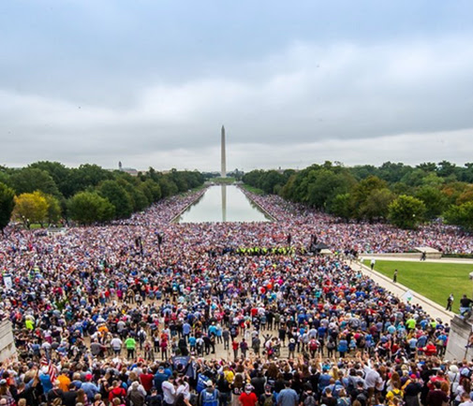
The March section that was to later join the Return Rally near the Washington Monument in the distance.
And on the same date it was great to see a new dimension in Australia with the Indigenous National Solemn Assembly with several thousand joined together by zoom.
Indigenous people from all over Australia came together in a truly remarkable event facilitated by the National Day of Prayer and Fasting team and the National Council of Churches with Indigenous Pastor Peter Walker and other pastors such as Pastor Tim Edwards, Rob Knight, Norman Miller, Robyn (Green) and her husband Anthony Beazley, Rodney Minniecon and Rodney Rivers.
One of their major concerns was the alarming rate of suicide particularly among younger people. Tragically one of the prayer warriors lost her son-in-law just days before the Assembly began. Suicide is now the highest cause of death among young Australians.
It is interesting that the fear of the spirit of death was the reason preventing the Hindu Buddhists from settling Australia. Two other major groups were coming south as well, including the Muslims who feared the spirit of Antichrist who they called Dedjdal. The other group were the Chinese who feared a kingdom of women! ( A History of Australia C.M.H. Clark Vol 1 pages 5-9 MUP)
Pastor Peter Walker spoke about the swallow mentioned in Psalm 84:3 which is a migratory bird, noting the difference to the sparrow also mentioned in the same verse. It is also interesting that on the previous page 4 of the book by Manning Clark just mentioned there were at least three major migrations prior to the Aborigines, that of the Negritos, Carpentarians and Murrayians.
Let’s not kid ourselves that the present migration will be the last one as we learn from history about the rise and fall of nations.
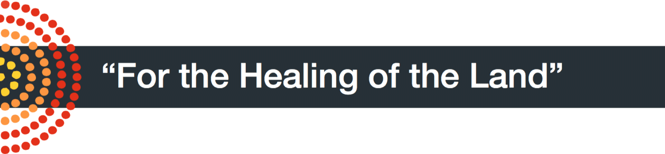
Among the many touching moments during the weekend, I found the Indigenous woman from Western Australia praying with her children kneeling to the ground laying their hands on the dusty earth pleading for the healing of the land, a truly sacred moment.
To quote Ps Peter Walker who found it hard to highlight the many cries as incense to God's throne: "We're believing for a breakthrough in the nation. Already we hear testimonies of women who have been healed and young Indigenous coming to the Lord".
The fervency of the prayers especially from the "weeping women of the desert", who could remember the wave of revival changing lives from the Elcho Island revival in the 70's as it moved south into Arnhem Land in the Top End and beyond.
Dr Lynore Geia, a Torres Strait Islander woman born and raised on Palm Island, a nursing and midwifery academic, pleaded for renewal and the restoration of family.

It brought real joy to those participants, such as Dan Armstrong and John Blacket who have longed to see the fruition of these prayers.
Certainly this time was a landmark in spiritual terms as we shared Communion together many times, hoping for a breakthrough in the heavenly realm, the ripple becoming a wave, the wave turning into a tsunami!

The National Solemn Assembly has been recorded with the Indigenous people sharing their dreams and aspirations for their families and country.
SOLEMN ASSEMBLY PRAYER
By Peter Walker
1. Father, I bring repentance before you for the sins and transgressions of my forebears.
2. I repent for the sins of idolatry, sorcery, necromancy, fornication, adultery, magic, divination, occultism, witchcraft, bloodshed, slavery, sexual perversion, injustice, oppression of the poor and the helpless, rebellion and evil dedications. Father forgive and cleanse us from these abominations through the Blood of Jesus Christ.
3. Father, I also repent for my direct or indirect participation and involvement in these sins. Forgive me, O Lord.
4. I receive a complete cleansing from all contaminations arising from these abominations in Jesus Name.
5. Right now, I send the Blood of Jesus to visit my roots and foundations and dissolve all satanic covenants, tokens and pacts, oaths, allegiances, and agreements associated with them.
6. Lord I repent of any broken covenants, and oaths I may have entered into knowingly, and unknowingly.
7. I render impotent and ineffective any covenants made on my behalf at any evil altar in Jesus Name.
8. We ask for forgiveness for not being the stewards of the land that he has called us to be and allowing defilement over the land.
9. Lord thank you for your great mercy that will avail for myself, my family members, and the nation through the Cross of Jesus Christ.
DECLARATION
By Rob Knight
I declare and decree that the National Solemn Assembly will deliver its God given mandate of uniting the Body of Christ to cause a reformation in Australia. This Godly reformation will start a move of God that will bring a shift in righteous God given mountain moving authority around the world.
Another National Solemn Assembly is planned for 2021.
For further Information contact Peter Walker <peter.walker.ministries@gmail.com>

