**Public Christian Symbols in Australia**

We are compiling a list of similar icons for the [www.chr.org.au](http://www.chr.org.au/) website and for the Inaugural [National Christian Heritage Sunday](http://www.nchs.net.au/) 3rd February 2013. Do you know of others?

Please contact [nacl@netwit.net.au](mailto:nacl@netwit.net.au)

**Sydney Fountains**

Amongst the many public Christian symbols in Australia are these remarkable drinking fountains in Sydney with the inscription from John 4:13-14

*"Whosoever drinketh of this water shall thirst again; But whosoever drinketh of the water that I shall give him shall never thirst."*

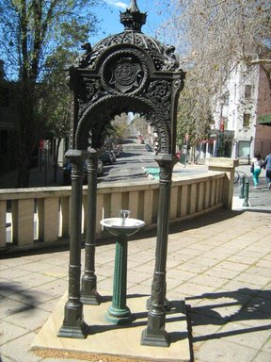

Above. Fountain cnr of Oxford and Riley Streets Sydney

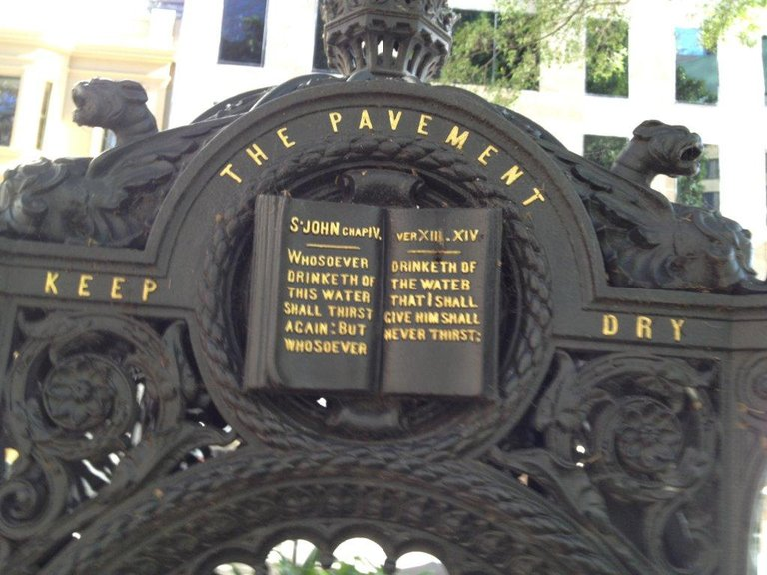

Above. Scripture highlighted on fountain in Macquarie Place cnr Bridge and Loftus Streets near Circular Quay

[Read more](https://memorialdrinkingfountains.wordpress.com/2014/07/14/sydneys-fountains/) of the Sydney fountains.

**Federation Pavilion, Centennial Park, Sydney**

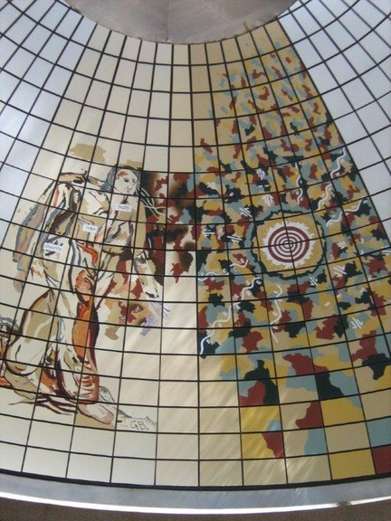

Pavilion erected in 1988 which contains the 1901 monument of the Federation of the six states.

The picture of the man contains the words: Faith, Hope & Charity - near tie, right chest & hip.

**Richard Johnson Square, Bligh and Hunter Sts, Sydney**

Memorial to the Bicentenary of Christian Education 1793-1993

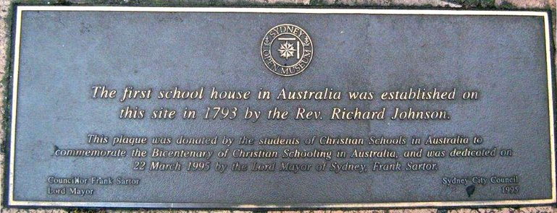

**Two Memorials Dedicated to the Memory of John Flynn**

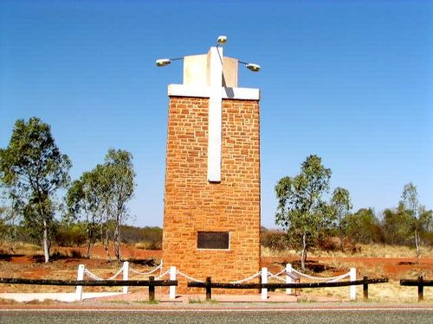

**Stuart Highway Memorial NT**

Commemorating Flynn of the Inland. The very Reverend John Flynn OBE. DD of the Presbyterian Church of Australia 1880-1951 His vision encompassed the continent. He established the Australian Inland Mission and founded the Flying Doctor Service. He brought lonely places a spiritual ministry and spread a mantle of safety over them by medicine, aviation and radio.

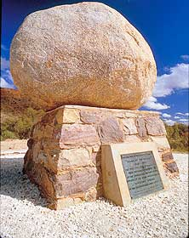

**John Flynn's Grave, near Alice Springs NT**

The John Flynn's Memorial Historical Reserve, located seven kms west of Alice Springs, is the resting place for the ashes of the Reverend John Flynn, founder of the Flying Doctor Service and the Australian Inland Mission.

The grave is on a low hill at the foot of the MacDonnell Ranges. The plaque expresses a lifetime achievement in just a few lines:

'His vision encompassed the continent. He established the Australian Inland Mission and founded the Royal Flying Doctor Service. He brought to lonely places a spiritual ministry and spread a mantle of safety over them by medicine and the radio.'

**Victorian Parliament**

The Vestibule is the main entrance Hall to the Victorian Parliament and was completed in 1879. This parliament was also used from 1901 to 1927 for the Commonwealth Parliament. In the centre of the Vestibule there is a mosaic of the Royal Crest with the words from the Book of Proverbs 11:14:

"Where no council is the people fall, but in the multitude of counsellors there is safety."

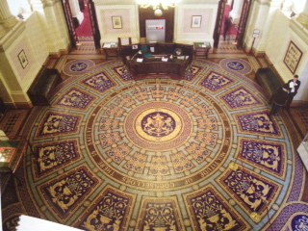

**Ebenezer Church**

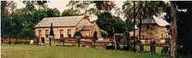

Ebenezer Church Is Australia's oldest church, est. 1809 at Ebenezer, NSW and the oldest extant school building in Australia.

Read more at <http://www.ebenezerchurch.org.au/index.htm>

[**Sheffield Murals - Christian Heritage**](http://www.sheffieldmurals.com/sheffield4.html)

[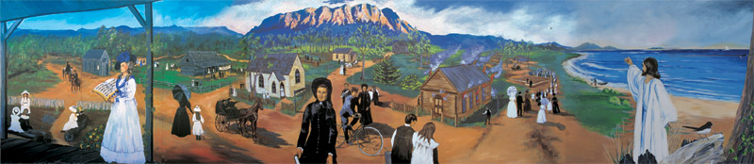](http://www.sheffieldmurals.com/sheffield4.html)

The historical roots of each Christian denomination in Kentish along with approximately 140 people are depicted in this mural. The mural shows the arrival of the first Methodist clergyman in 1860, the Christian Brethren evangelists meeting in farmers’ barns and the building of the Anglican and Salvation Army Churches.

We also see the huge crowds that came to respond to Joseph Lyons (later to become Prime Minister) as he appealed for funds to build the Catholic Church and the spectacular fire which gutted the Baptist Tabernacle in 1930. The mural includes an impression of the many who have left for overseas in mission fields.

Painted in 1988 by: Cheyne Purdue  
Location: Pioneer Crescent, Sheffield, Tasmania  
Size: 12m x 2.4m  
© Sheffield Inc.

**Queensland Parliament House Bible Verse**

The two ground floor stained glass windows feature text from The Bible, Psalm 127-1, stating:

Except the Lord build the house, they labour but in vain that build it.

Except the Lord keep the city, the watchman waketh but in vain.

This text was chosen by Mrs Elizabeth Emily O’Connell (nee le Geyt), who was the wife of Sir Maurice Charles O’Connell, the second President of the Legislative Council.

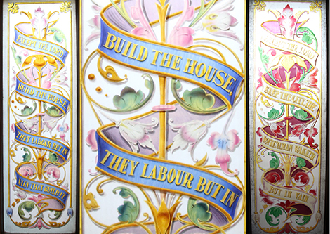

[**Link**](https://www.parliament.qld.gov.au/explore/history/parliament-house/inside-parliament-house/entrance-staircase)

The Bible Museum St Arnaud Victoria  
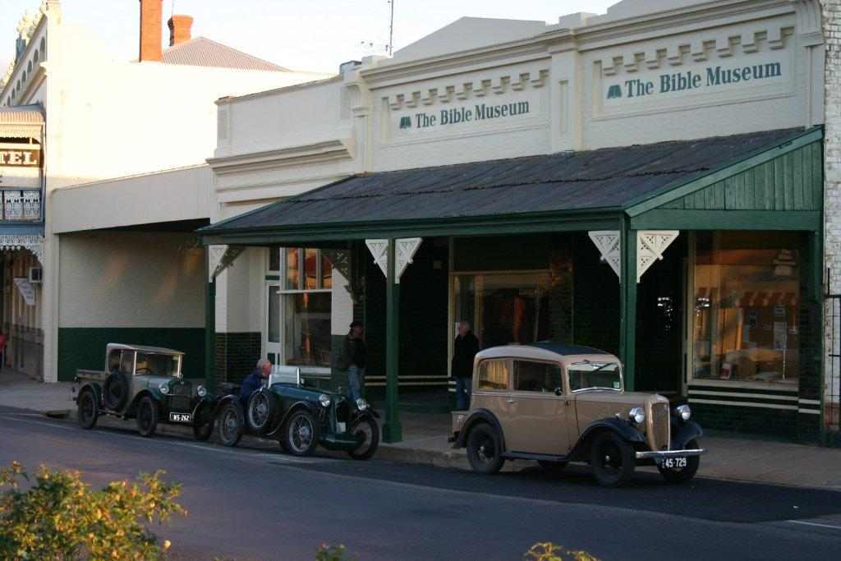

|  |
| --- |
| **Exhibits** |

|  |
| --- |
| **Our displays are constantly changing as new items are added to the collection. The displays include:**   * **History of the Bible** * **Bibles from around the World** * **400th Anniversary of the King James Bible** * **Illuminated Bibles and Manuscripts** * **Fruits and Food of the Bible** * **Women of the Bible** * **The story of the Bible** * **Musical Instruments of the Bible** * **Coins and Stamps related to the Bible** * **Archeology and the Bible** * **Jewish Oil Lamps** * **Buildings in the Bible (The Jewish Temples, Tabernacle, Masada, Patriarch's Tomb)** |

<https://www.thebiblemuseum.com.au/>