**Revival In Melbourne!**

Over 100 years ago Revival came to Melbourne 10,000 a night at the Royal Exhibition Building May 1902. Did You Know There Was A Revival In Melbourne 100 Years Ago?

In 1898 a petition with 15,300 signatures was sent to D.L.Moody in USA asking him to come and lead a crusade. He died before he could come, but in 1902, R.A. Torrey came and led a crusade at the Exhibition Building. With the population of Melbourne then 500,000, over 250,000 people came every week!

8000 people came to Christ !

**[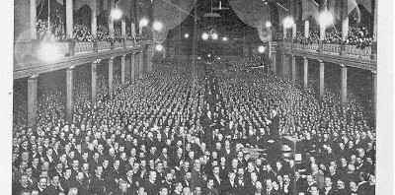](http://partnersinprayer.org.au/revive-melbourne-again-lord/)**

**The Secret**

*All the Evangelical Churches in Melbourne were working together.  
They held 1700 weekly prayer groups across Melbourne!  
They appointed 45 evangelists to preach in every area of the city.*

“The Vital Elements: Unity And Prayer”

*From: “Evangelical Christianity in Australia” Stuart Piggin (Oxford)*

The Many Revivals In Melbourne

* 1843
* 1859 Started at Brighton
* 1879
* 1902 The Great Revival – with R.A. Torrey and Charles Alexander
* 1926 Sunshine Revival
* 1959 Billy Graham Crusade was the largest, most successful evangelistic campaign in human history. 719,000 attended in Melbourne with 26,440 inquirers “More prayer has been made for the Melbourne and Sydney crusades than for any single event in the whole history of the Christian Church” Billy Graham 1958

How did the Gospel influence the shape of Australian society?

**Read more at** [**http://partnersinprayer.org.au/revive-melbourne-again-lord/**](http://partnersinprayer.org.au/revive-melbourne-again-lord/)

Source: www.transformingmelbourne.org