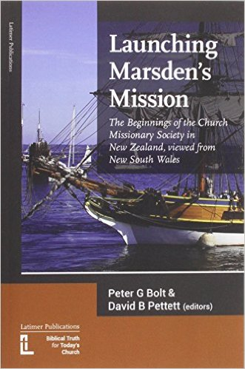

In 1794 the Rev Samuel Marsden became the second Chaplain to the Colony of New South Wales. Both Marsden and the first Chaplain, the Rev Richard Johnson, came to the Colony under the sponsorship of the Church of England Evangelicals. They had high hopes that New South Wales would be the base from which the 'everlasting gospel' would sound forth to achieve the salvation of the 'poor benighted heathens' of the South Seas. To this end Marsden began the mission to New Zealand on Christmas Day, 1814. As the senior chaplain in New South Wales Marsden's interest in the Māori people began in 1805 when chief Te Pahi from the Bay of Islands visited Sydney. Marsden developed close relationships with Te Pahi and later his nephew, Ruatara. After a two year furlough in England recruiting more chaplains and school teachers for the Colony and missionaries for New Zealand Marsden arrived back in New South Wales in February 1810 with Ruatara who had been in England. Plans for the mission were set back because of an incident in New Zealand that saw most of the crew of the Boyd killed. Marsden spent the next four years getting to the bottom of the case and preparing for the mission. Marsden's reputation as a harsh magistrate in New South Wales has left a lasting stain and most today remember him as the 'Flogging Parson'. Despite some modern attempts in New Zealand to besmirch his name there also he is more fondly remembered as the 'Apostle to the Māori'. This book does not attempt to recast Marsden as a man with no faults. No attempt is made to gloss over the things that history has judged that he should not have done and the things he neglected. Rather, alongside these this book places the great work Marsden did to take the gospel to the people of New Zealand. This book is a celebration of that mission and Marsden's preparations for it.

This volume arose from the Moore Theological College Library Day 2013 and is published in conjunction with the 200th anniversary celebrations of Marsden's first sermon in the Bay of Islands.

Paperback available from Amazon by clicking here <https://www.amazon.com/Launching-Marsdens-Mission-Beginnings-Missionary/dp/190632722X/ref=sr_1_4?s=books&ie=UTF8&qid=1473919817&sr=1-4&keywords=Peter+G+Bolt>