[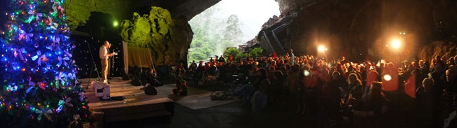](http://www.jenolancaves.org.au/images/sendbinary.asp?path=imagesDB/wysiwyg/Carols-in-the-Caves-Grand-Arch.jpg&maxwidth=373&maxheight=93)

# History of underground church services at Jenolan Caves

**There is a Christmas Church Service, deep underground, in the Cathedral Chamber of the Lucas Cave. All are welcome to this free, non-denominational service. Note that it is 252 steep stair steps to reach the Cathedral Chamber. Once inside, you can sit, relax, hear the Christmas message.  After catching your breath, you can sing well-known Christmas Carols and enjoy a beautiful solo, in the acoustically perfect chamber.**

**The cave is a constant 16 degrees Celsius. So, although it might be hot above ground, worshippers should bring warm clothes for the one-hour service. Although Jenolan Caves hosts many underground weddings, it holds church services twice a year only - at Easter and Christmas - organised by a group of dedicated Christians on Jenolan's staff.**

**Like any other Australian rural community, for most of its 174 year history, the residents of Jenolan Caves attended church. Until the late 1960s, underground church services were held weekly. In the 1870s, the services were Methodist. But over the years, the Cathedral Chamber was used by other denominations. Amazingly, in the 1960s, services were broadcast regularly from the Cathedral Chamber and aired live on Sydney radio station, 2GB! In 2008, World Youth Day saw the Cathedral Chamber used for Catholic Mass, approximately 50 times, over 8 days - each Mass accommodating a full busload of pilgrims!**

**As Jenolan's early cave explorers mapped their way through unfamiliar passages and caverns, they named a multitude of formations after familiar stories from the Bible. Jenolan's Cathedral Chamber was named not only because of its huge dimensions (54 metres high), but because its massive formations reminded explorers of church features - the 'baptismal font', the 'pulpit', 'the organ', 'the belfry', 'the organ pipes' and 'the cathedral windows'.**

**Read more at:** [**http://www.jenolancaves.org.au/event.asp?pid=74&id=10&sdid=27**](http://www.jenolancaves.org.au/event.asp?pid=74&id=10&sdid=27)