HENRY JAMES HOLDEN

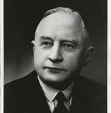
Sir Henry James Holden (1859-1926), saddler, carriage-trimmer and motor-body manufacturer was born on 18 July 1859 in Adelaide, eldest of nine children of James Alexander Holden (1835-1887) and his wife Mary Elizabeth.
He was president of the Baptist Union for twenty-one years, a deacon for twenty-five and a Sunday-school superintendent. In 1904 he established the Norwood Cottage Homes for the aged poor. He was president of the Young Men's Christian Association and official visitor to the Parkside Asylum. When visiting England in 1911 he was commissioned to investigate management of hospitals for the mentally defective. A diabetic, in his last years Holden appeared infrequently at board meetings. He died at Norwood on 6 March 1926, survived by his wife, two sons and three daughters one of whom was South Australia's first female senator in the Commonwealth Parliament.
By 1923 Holden's employed over a thousand men and produced 240 car-bodies per week (for numerous makes of imported chassis), more than half the national output. Rapidly expanding demand required innovative production methods, and repeated restructuring of the firm's finances to provide capital. In April the company expanded its plant to a 22-acre (9 ha) site at Woodville; production rose from 6661 bodies in 1922 to 22,060 in 1924. Increasingly under Edward's leadership, the Woodville development incorporated the latest technology, including automated production lines, and became the largest plant of its type outside North America.
By 1929 the company employed 3,400 workers and was the biggest automotive bodybuilder in the British Empire.
In October 1929 the plant closed temporarily for lack of continuous work, and in January 1930 Holden set out for the United States to discuss amalgamation with General Motors. In February 1931, General Motors offered £1,116,000 for Holden's, which was ultimately accepted. This reduced the cash burden of the merger for General Motors, while giving it complete control while maintaining an Australian character in name, ownership and management.
Holden was appointed Executive Chairman of Directors and joint Managing Director of General Motors-Holden's Ltd. in August 1931 and later sole Managing Director until 1934 then remained Chairman until ill health forced his resignation in January 1947.
As well as being the State's leading industrialist, Henry Holden contributed substantially to civic life. He was mayor of Kensington and Norwood for eight years, a member of the Norwood School Board, and as a foundation member of the Municipal Tramways Trust initiated moves for electrification of the system. President of the Municipal Councils Association in 1903 and later vice-president, he acted as chief magistrate in the eastern suburbs and was chairman of a committee formed to draft a bill for town planning.
At its peak in the 1960s, Holden had around 24,000 employees when models like the EH were dominating the sales charts.
During the war years, Holden's car production was diverted to the construction of vehicle bodies, weapons, aircraft and engines.
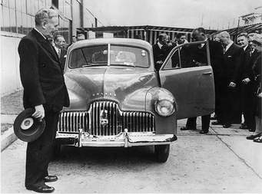
In 1948, the company finally achieved its long-term goal of manufacturing the first all-Australian motor vehicle. On November 29, Prime Minister Ben Chifley unveiled the first Holden 48-215, which became affectionately known as the "FX". See picture above
The FX, was a robust and economical family sedan, designed for the Australian environment.
The price was set at $733 (including tax), which represented a staggering 94 weeks wages for the average worker at the time. Despite this, the car was an immediate success and Holden could not satisfy demand quickly enough.
18,000 people had signed up and paid their deposit without even having seen the vehicle!

Read more: Australian Dictionary of Biography and Wikipedia!
And the rest is history!

