Australia’s Joint Destiny with America
By Dr Graham McLennan
Twenty eight nations were involved in prayer and fasting for the USA in 2013.
The Australian National Day of Prayer & Fasting, for the first time,
called a world-wide 72 hours of Prayer and Fasting for the USA.
Again in 30 April – 1 May 2014 the team behind Australia’s National Day of Prayer and Fasting agreed for a global call to the nations of the world for 48 hours of prayer and fasting for the USA.
This year we are again calling people to Pray & Fast for the USA for seven days from April 30th through to May 6 th 2015, the week leading up to the 7th May as we in Australia believe it is our turn to bless the nation of America through prayer and fasting according to 2 Chronicles 7:14. We join together to pray that God will raise up united prayer as one voice for the USA.
We in Australia are grateful for the protection that America gave Australia and the nations of the free world during World War II.
The Battle of the Coral Sea led by the USA was the turning point in the Second World War and saved many of the South Pacific nations including Australia from destruction. It was on the Island of Espiritu Santo Vanuatu (which last month suffered from a category 5 Cyclone), American troops were based fighting off the Japanese in WW11. An American naval officer James Michener based there, wrote a novel “South Pacific” later adapted as a musical play written by Rogers and Hammerstein.
In 1606 a Catholic Portuguese navigator best known for his involvement with Spanish voyages of discovery in the Pacific Ocean, proclaimed this region to the south of Espiritu Santo on the Day of Pentecost, 14th May, 1606
Let the heavens, the earth, the waters with all their creatures, and those present, witness that I, Captain Pedro Ferdinand de Quiros...in the name of Jesus Christ... hoist this emblem of the holy cross on which His person was crucified and whereon He gave His life for the ransom and remedy of all the human race...on this day of Pentecost, 14th May....I take possession of all this part of the south as far as the pole in the name of Jesus...which from now on shall be called the southern land of the Holy Ghost...and this always and forever...and to the end that to all natives, in all the said lands, the holy and sacred evangel may be preached zealously and openly.
Would you believe this prophetic word was to come true as American troops protected all the islands to the south with no casualties.
To the north severe casualties took place as the first major offensive took place against the Japanese on the Solomon Islands especially on Guadalcanal in August 1942. Two attempts several months earlier by the Japanese to continue their strategic initiative and offensively extend their outer defensive perimeter in the south and central Pacific to where they could threaten Australia and Hawaii or the US West Coast were thwarted at the naval battles of Coral Sea and Midway respectively. Coral Sea was a tactical stalemate, but a strategic Allied victory which became clear only much later. Midway was not only the Allies' first clear major victory against the Japanese, it significantly reduced the offensive capability of Japan's carrier forces.
Serving in the military myself in the Australian army to assist our American friends in Vietnam, Australian troops have assisted in other theatres of war including the most recent, fighting IS terrorism. Whilst training as an army officer, one of the principles of warfare we learnt was to know our enemy, indeed a principle in spiritual warfare today.
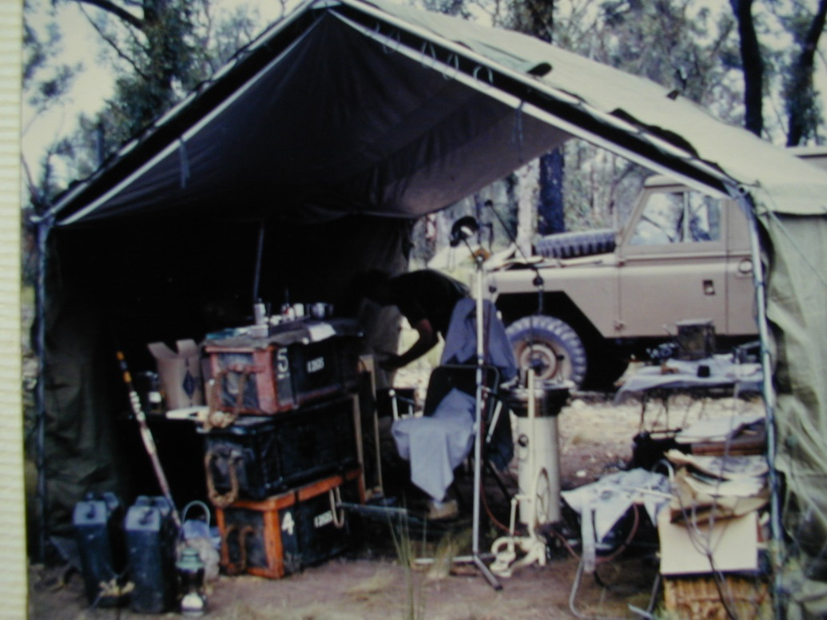
Preparing 7RAR troops for Vietnam 1969 whilst attached to our Artillery Unit.
Because of the ANZUS treaty we have become like brothers. God spare us from another war to bring us together again.
We know that freedom has its cost. At Easter time we have remembered the suffering of Jesus for mankind on the cross, a symbol marked on many graves though out the world. We remember our own war dead, the sacrifice of over 100,000 Australian military personnel who died with the symbol of the cross which reminds us of the verse in Colossians 2:15 "having disarmed the powers and authorities, Jesus made a public spectacle of them, triumphing over them on the cross".
This week on ANZAC Day the 25th of April we remember those who served our nation at war with official services, reading Psalm 23, John 15:9-13 … Greater love has no man than this, that a man lay down his life for his friends… along with the Lord’s Prayer and hymns such as Abide with me and O God, Our help in Ages Past.
The Australian and New Zealand armed forces commonly known as ANZAC's have served in both WW1 and WW2 as well as other theatres of war. Amongst the major achievements has been the Australian Light Horse charge at Beersheba with 800 men on horseback on October 31st, 1917, when God used one of the most recent nations in the world to take Jerusalem from the Turks and Germans, liberating Jerusalem from four hundred years of rule by the Turkish Ottoman Empire, eleven Crusades throughout history had been unable to achieve, the military genius of Napoleon and the British Army with 50,000 British Infantry had fought bravely but were driven back, was accomplished by 800 fresh-faced Australian Light Horsemen at Beersheba. On 31st October 1917, the day of the Beersheba charge, the British Government drafted the Balfour Declaration, which was the foundation for the recognition of the State of Israel.
It is important to remember as Karl Marx said in his famous dictum remarked upon by Winston Churchill ( Never Give In. The Extraordinary Character of Winston Churchill. p190.)
“ One of the signs of a great society is the diligence with which it passes culture from one generation to the next. This culture is the embodiment of everything the people of that society hold dear; its religious faith, its heroes . . . When one generation no longer esteems its own heritage and fails to pass the torch to its own children, it is saying in essence that the very foundational principles and experiences that make it the society it is, are no longer valid. This of course, leaves that generation without a sense of definition or direction, making them the fulfilment of Karl Marx’s dictum, ‘A people without a heritage are easily persuaded.’ What is required when this happens and the society has lost its way is for leaders to arise who have not forgotten the discarded legacy and who love it with all their hearts. They can then become the voice of that lost generation, wooing an errant generation back to the faith of their fathers, back to the ancient foundations and the bedrock values . . . Those who seek to plan the future, should not forget the inheritance they have received from the past. If the present tries to sit in judgement of the past it will lose the future.”

Not dissimilar to the words in Psalm 78
¹ My people, hear my teaching;
listen to the words of my mouth.
² I will open my mouth with a parable;
I will utter hidden things, things from of old—
³ things we have heard and known,
things our ancestors have told us.
⁴ We will not hide them from their descendants;
we will tell the next generation
the praiseworthy deeds of the Lord,
his power, and the wonders he has done.
He established a testimony in Jacob
and appointed a law in Israel,
which he commanded our fathers
to teach to their children,
⁶ that the next generation might know them,
the children yet unborn,
and arise and tell them to their children,
⁷ so that they should set their hope in God
and not forget the works of God,
but keep his commandments;

My own personal journey with the United States began in 1974 when we visited the US to train with Teen Challenge. My wife and I and two young daughters escaped being killed arriving in Brooklyn, and later myself with gang fights in the Bronx!
Again in 1980 we returned to the US for several months involved with YWAM. In San Francisco we learnt about America’s Christian heritage wondering if we in Australia had any.
When asked who was our national hero, I replied “Ned Kelly”. I was asked,
“what did he do?” To their surprise I said he robbed people and killed policemen! There is some recent evidence that Ned later became a Christian before facing the gallows. (Did you know the Japanese leader of that “ day of infamy” the bombing of Pearl Harbour was also to become a Christian!
We learnt about such things as Christopher Columbus who was inspired by the scriptures to discover the Americas
"...It was the Lord who put into my mind - I could feel His hand upon me the fact that it would be possible to sail from here to the Indies. All who heard of my project rejected it with laughter, ridiculing me... There is no question that the inspiration was from the Holy Spirit, because he comforted me with rays of marvellous illumination from the Holy Scriptures... For the execution of the journey to the Indies I did not make use of intelligence, mathematics, or maps. It is simply the fulfilment of what Isaiah had prophesied... No one should fear to undertake any task in the name of our Saviour, if it is just and if the intention is purely for His Holy service... the fact that the Gospel must still be preached to so many lands in such a short time - this is what convinces me". "Book of Prophecies", Christopher Columbus

Columbus' voyage ultimately led to the first permanent English settlement in America, at Jamestown. There they placed a cross at Cape Henry (now Virginia Beach) on April 29, 1607, claiming America for God as his vehicle for spreading the gospel to every nation.

During this time we helped organise the Washington for Jesus rally. One of our members looked like Abraham Lincoln and gave addresses, even at the Lincoln Memorial.
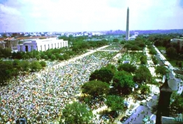 Washington for Jesus USA 1980

I still remember words such as Lincoln’s famous Gettysburg address which concludes:
“…The brave men, living and dead, who struggled here, have consecrated it, far above our poor power to add or detract. The world will little note, nor long remember what we say here, but it can never forget what they did here. It is for us the living, rather, to be dedicated here to the unfinished work which they who fought here have thus far so nobly advanced. It is rather for us to be here dedicated to the great task remaining before us—that from these honored dead we take increased devotion to that cause for which they gave the last full measure of devotion—that we here highly resolve that these dead shall not have died in vain—that this nation, under God, shall have a new birth of freedom—and that government of the people, by the people, for the people, shall not perish from the earth.”
Returning home we had a burden for our own nation resulting in the National Gathering in 1988 where 40,000 gathered around our new Commonwealth Parliament building to open it in prayer.
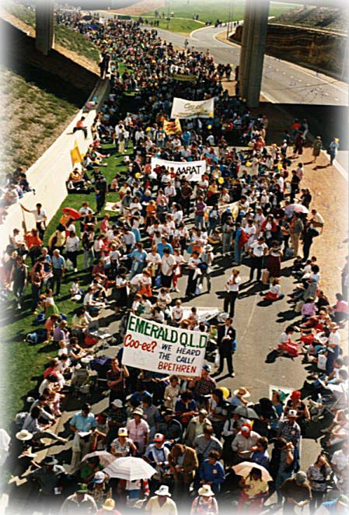
National Gathering Canberra Australia 1988
Also we began researching our own Christian heritage publishing several books and other material on our website www.chr.org.au which shows many documents, individuals, institutions and events such as the Christian settlement of South Australia; our Christian Constitutional Monarchy where the Queen swears to uphold the Royal law- God’s word; many explorers whose faith sustained them, the faith of many of the early governors all who were opposed to the slavery movement as well as the inclusion of Relying of the Blessing of Almighty God in our Constitution which also included debate about the United States of America being "A Christian Nation":
In1892 the United States Supreme Court determined, in the case of the Church of the Holy Trinity vs. United States (143 United States 457 1892), that America was a Christian nation from its earliest days. The court opinion, delivered by Justice Josiah Brewer, was an exhaustive study of the historical and legal evidence for America's Christian heritage. After examining hundreds of court cases, state constitutions, and other historical documents, the court came to the following conclusion:
"Our laws and our institutions must necessarily be based upon and embody the teachings of the Redeemer of mankind. It is impossible that it should be otherwise; and in this sense and to this extent our civilization and institutions are emphatically Christian ... This is a religious people. This is historically true. From the discovery of this continent to the present hour there is a single voice making this affirmation... We find everywhere a clear recognition of the same truth... These, and many other matters which might be noticed, add a volume of unofficial declarations to the mass of organic utterances that this is a Christian nation."

We also discovered that our nation also had many Days of Prayer as described in this article by clicking here.
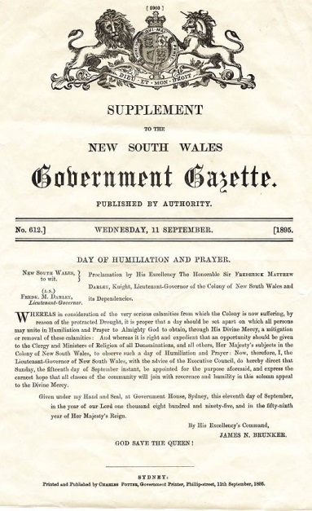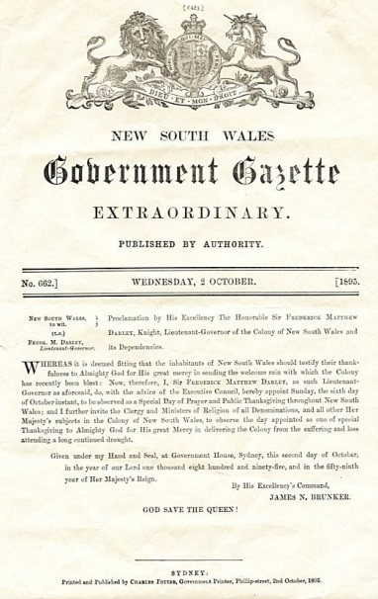
Franklyn Graham is visiting all US states before the Presidential elections.
A news release states
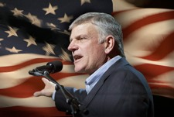
On the 16th April, Franklin Graham announced he will embark on a 50 state tour of the United States next year. He made the following statement:
America is in trouble. At 62 years of age, I've lived long enough to learn that neither the Democrats nor the Republicans can turn this country around; no political party or politician is the answer.
The only hope for this country is Almighty God and His Son Jesus Christ.
Next year I am planning to travel to all 50 states to conduct prayer rallies - we are calling this the Decision America Tour. I want to challenge Christians to boldly live out their faith and to pray for our nation and its leaders. I want to encourage Christians to get out and vote, and to cast their ballots for candidates who uphold Biblical principles.
I want to strongly urge Christians to run for public office at every level - local, state, and federal. We will not be endorsing any political candidates, but I will be proclaiming the truth of God's Gospel in every state. More details will come later. I hope you will start praying with us now.”
In closing I would like to say that some Australian’s have been instrumental in helping America and the free world. Such is the story of a Dr Charles Schwarz who founded the Christian Anti-Communism Crusade which was very active in the USA in the 1960’s and 70’s and who influenced people such as Ronald Reagan to stand up against Russia seeing the walls fall in Berlin and beyond.
President Reagan was a great orator. Two of his outstanding speeches were to the British Parliament and to the National Association of Evangelicals in Fort Lauderdale, or the “Evil Empire” speech.
Dr Schwarz congratulated Tony Dolan, the speechwriter who helped prepare these speeches, and he replied, “You should have liked it. I took it all from you.” He sent a copy of the “Evil Empire” speech to Schwarz with this note: “I thought you might like to see the oak tree that has grown from the acorn which you planted so many years ago.”
May God raise up such great leaders in our countries again.
We know that the devil comes to steal, kill and destroy. We need to stand firm, keep hold of our Christian faith and nation’s Christian symbolism such as our Constitutional Christian Monarchy where the Queen was presented with the Bible during her Coronation Service:
"to keep your Majesty ever mindful of the law and the Gospel of God as the rule for the whole of life and government of Christian Princes, we present you with this Book, the most valuable thing this world affords. Here is wisdom; this is the royal law; these are the lively oracles of God."
When the Orb was presented to the Queen:
"Receive this Orb set under the cross, and remember that the whole world is subject to the power and empire of Christ our Redeemer."
Our lands need nothing short of national transformation. It was a privilege to study under the most influential Christian of the last century, the great American, Dr Francis Schaeffer in L’Abri Switzerland in 1974. My desk mate’s father was to shortly become the President of the US.
Schaeffer influenced us to redeem our culture, to think biblically in such areas as education, media, government, business and the family. Consequently we commenced Christian schools, Christian radio stations and stood with political candidates to protect family life, one of whom still remains in parliament after 34 years!
So you can see both America and Australia do have much in common. We both have a strong Christian heritage and in that respect we have a joint destiny in Jesus Christ. I believe this is proven by the enormous response to the Elijah List support of the Australian led call for the world to join together in Seven Days of Praying and Fasting for the USA. This period of prayer extends from the 30th April which marks the USA Day of Repentance right up to the 6th April 2015 which is the eve of the National Day of Prayer. It is my belief that this Destiny will be fully revealed as we continue to support each other in prayer.
May God grant it for the sake of future generations. We should not place our children on the altar of secular humanistic education and entertainment.
We need to cry out to God like the persistent widow described in Luke 18.
Or is the cost too much?
May God Grant America a Double Blessing!

