29th April 1770- Captain Cook Arrival at Botany Bay. 250th Celebrations Wednesday 29 April 2020
(Very little recognition as all functions were cancelled due to the Covid-19 Pandemic)
Excerpt from Southland of the Holy Spirit

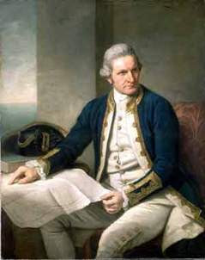
"Nelson and "Cook are the two most revered names in...the Royal Navy", but more importantly, Captain James Cook is the man who "discovered"Australia , as every Australian school child knows. He was the "greatest combination of seaman, explorer, navigator, and cartographer that the world has known".
Cook was born at Marton-in-Cleveland, a small village in north-east Yorkshire on 27 October 1728 . His father, James Cook, was a Scottish farm labourer and his mother, Grace (Pace), a Yorkshire girl. They lived in a two-roomed, clay-built thatched cottage, where their son, James, was born and was baptised in the village church of St Cuthbert on 3 November. The young James inherited a strong physique which was to equip him for a rugged life at sea. (Four younger brothers and sisters died in infancy.) As a boy, Cook learned his letters from Mrs Walker, whose husband farmed Marton Grange. To pay for his education, Cook helped with the farm chores and ran errands. As a farm boy, he learned good work habits from his father and developed an eye for the land, which was useful to him later in his explorations. About 1736, Cook's father was made a "hind" or farm-manager, to Thomas Skottowe, of Airyholme farm near Ayton, a larger village four miles from Marton. This promotion would suggest Cook senior was a man of steadiness, sobriety and intelligence. One of Skottowe's sons, noticing Cook junior had some brains, paid the small fees necessary to send him to Postgate School at Ayton, where the master, Mr Pullen, taught Cook the three R's and catechism. He was good at arithmetic, but Cook did not distinguish himself academically. There were no clues of early genius, but one report that has survived from the 1740s hinted at certain character qualities that attributed to his rise to fame:..
In 1745, Cook left home. His proficiency in arithmetic helped to get him a job as a shop boy with William Sanderson, grocer and haberdasher, at Staithes, a small but important North Sea fishing port. It was Cook's first taste of the sea. At seventeen, the life of the strong Yorkshire fishermen fascinated him. Between groceries and ribbons, Cook caught glimpses of them--bent over flat-bottomed boats; hauling baskets of fish; coiling long loops of rope; drying nets in the wind; vanishing into the night. The smells of the beach, wet tar, tangled seaweed, and fish were not the smells of the barnyard, but they stirred him. The long procession of white sails against the grey stormy skyline lured and challenged him. However, Cook did his job faithfully for eighteen months and as a result of his diligence, Sanderson personally took him over to Whitby ten miles away and made arrangements for his formal apprenticeship, as "a three year servant", to John Walker, a respected Quaker ship-owner, who specialised in the colliery trade.
The Quaker connection in Whitby was very strong. The first meeting house was built in 1676 and many of the buildings in the town reflected a Quaker dignity and restraint, including the Walker's house in Haggersgate, where Cook lodged. It is certain that the devout Walker family was an important influence in Cook's life. After his apprenticeship, he continued to stay with them between voyages until his marriage to Elizabeth Batts on 21 December 1762. It was Walker who noted Cook spent many hours studying navigation, astronomy and mathematics. Cook continued this habit all his life, a habit that was largely responsible for his later rise to fame in the Royal Navy
Whitby, a port town of 10,000 people, was famous for its ship-building yards. Whitbymen owned over two hundred ships; they traded up and down the English eastern coast, the Baltic, the Mediterranean, America, India and the Orient. The Walkers were involved in the coal trade which was regarded as "a nursery of seamen". Coal was the chief commodity of the northern counties, but the east coast of England was known for its treacherous coast and its unreliable tides. The North Sea was not to be trusted. Learning to navigate its waters was a tough "nursery" for seaman Cook, but the hard lessons he learned prepared him for difficult distant unknown coastlines, just as dangerous. Walker, confident in Cook's competence as a seaman, offered him a command of the Friendship,, a merchant ship, but "Cook had always an ambition to go into the navy".
So in 1755, Cook, passing up Walker's offer, joined the Royal Navy as an able seaman. This was an extraordinary decision--to join the lowest rank in the navy in an age when the navy was known for its brutality. A sailor's life was hard enough in the merchant service. However, the navy was so unpopular that men had to be continually pressed into its service. Its physical amenities, as well as its food, and its pay, were worse than the merchant service. Its discipline was also harsh, and its sickness record was dreadful. Cook never explained the reasons for his decision. Possibly he felt it was his duty to do his part in protecting his country against the French in the impending Seven Years' War. We will never know. Cook was an intensely secretive man. We have no record of his internal life. Even Cook's daily log, which he kept faithfully the rest of his life, revealed very little about the man.
To be offered a command at twenty-seven showed that Cook possessed exceptional abilities in navigation, cartography, and leadership--which accounted for his rapid rise in the navy. Within a month of joining the Navy, he became master's mate; in two years he rose to boatswain and then to master. As master, the senior non-commissioned officer, Cook was in charge of the running of the ship. At the same time he continued with his studies in navigation, mathematics, astronomy and cartography. The mastering of these subjects, along with the tough conditioning of naval life, was to prepare him for the later stresses of the Pacific.
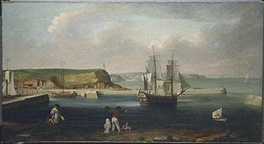
Earl of Pembroke, later HMS Endeavour, leaving Whitby Harbour in 1768. By Thomas Luny, dated 1790

Cook was an Anglican. His son Hugh was to enter the Anglican ministry, but died prematurely. Several writers on Cook referred to him as a Christian. Cook was a good man: above reproach in his morals; moderate in all things; compassionate and conciliatory in his treatment of the natives, always concerned about the welfare of his men; a man of great courage and determination; cool and just in judgement; controlled in speech even when angry. He would not allow profanity on board (which even professing Christians tolerate these days). He required his men to wear clean clothes on Sunday, and, on occasions he conducted divine service for his crew. (Recorded examples are 14,21 May 1769.) This would suggest that he certainly would have been sympathetic, not indifferent or hostile, to the faith.
Cook's wife gave him a Prayer Book, which he probably read in order to name a number of places discovered on significant days, such as the Whitsundays, Trinity Bay , Christmas Island , and Pentecost Islands...
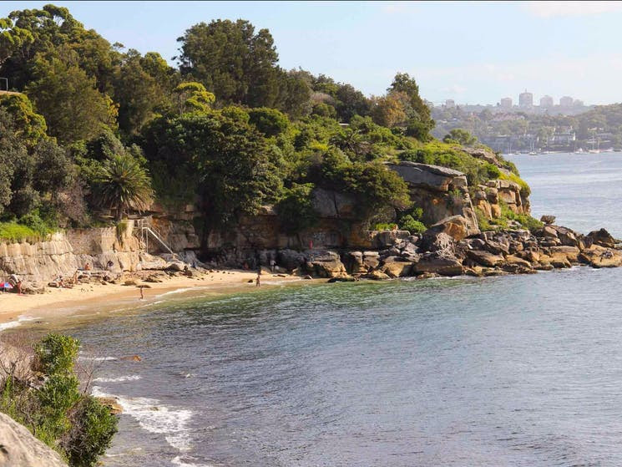
Cook's landing place at Botany Bay.
In 1770, Lieutenant (later Captain) James Cook landed at Botany Bay’s Inscription Point. He and his Endeavour crew stayed in the area for eight days and had a dramatic impact on Australian history.
Located near Silver Beach on the Kurnell Peninsula headland, Cook’s landing place is a popular Sydney attraction. Now heritage-listed, this reserve interprets the story of the meeting of European and Aboriginal cultures.
Visit Kamay Botany Bay National Park to discover Captain Cook’s landing place yourself. The best way to get there is along the Burrawang walk that features a soundscape of Aboriginal children's laughter. As you pass over the dune you'll see views of the bay where the Endeavour was first sighted. A small plaque marks the location where Captain Cook landed.
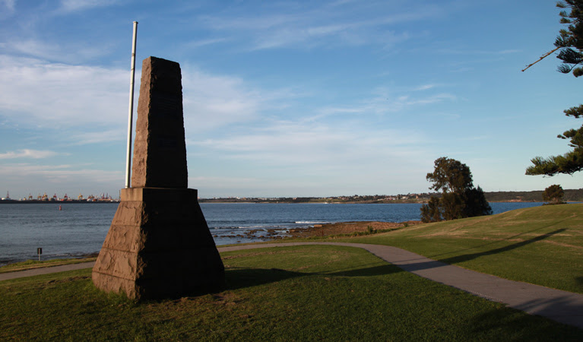
See also this link at Botany Bay
... After Cook continued to sail up the east coast, an incident occurred that almost terminated the voyage and their lives. There was a danger lurking beneath the waters of which Cook was unaware. It was the Great Barrier Reef. On Trinity Sunday, 10 June, the Endeavour struck a reef and stuck fast. After much work, the crew managed to free her and steered the damaged ship towards a river-mouth, where the banks were suited to laying the vessel ashore for repairs. That was 16 June. It was not until 4 August that Cook was ready to leave, but it was not long before the Endeavour was headed for the reef again. Without any wind and the seas being too deep to cast anchor, the ship was slowly but surely driven by the force of the tides towards certain destruction. Cook knew the Endeavour would smash and sink in a moment when it struck that perpendicular wall. The men manned the boats and tried to tow her away; it was useless. They were eighty yards away when "suddenly, a little breath of air moved, blew for a few minutes, faded, the merest cat's-paw". It was enough to carry them towards a narrow opening in the reef, but there was still no wind. How much longer could the Endeavour endure? Another narrow opening was seen in the reef and Cook pulled the head of the ship around. At last a light breeze sprang up, and with the tide being in their favour, hurried the vessel through this "Providential Channel" as Cook named it, as he anchored in safe waters.
It had been "the narrowest escape we ever had and had it not been for the immediate help of Providence we must inevitably have perished", said Richard Pickersgill, the master's mate. Cook, in his entry for 16 August 1770, after describing their desperate situation, wrote, "It pleased God at this very juncture to send us a light air of wind, which, with the help of our boats, carried us about half a cable's length from the present danger".
Just as the "i" has been taken out in Pedro Fernandez de Quiros naming Austrialia del Espiritu Santo the Southland of the Holy Spirit so also the above quote has been slightly changed in later editions of Cooks Journal. Footnote Beaglehole p247 Hakluyt Society 1974.
http://rupertgerritsen.tripod.com/pdf/published/Austrialia_Globe_72_2013_pp23-30.pdf
Read more with references and footnotes.
PS
Cook took Divine Service on board such as recorded on the 14,21 May 1769

