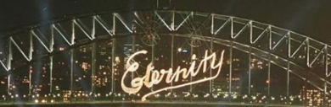
Remember when millions of people around the world saw this image on our Sydney Harbour Bridge in 2000? Then the book by Roy Williams and on the DIDUNO website - http://www.diduno.info/arthur-stace-mr-eternity/...He toiled for decades in charitable work for unemployed, alcoholic and mentally-ill men, initially under R.B.S. Hammond’s supervision but ultimately on his own initiative.
On New Year’s Eve 1999, an estimated 2 billion television viewers around the world watched Sydney’s spectacular millennium celebrations. Sydney was to host the Olympic Games in 2000 and the city was the centre of national and global attention.
At the climax of the celebrations, just after midnight on 1 January 2000, the Harbour Bridge was lit up with the word Eternity. The huge crowds clustered around the harbour foreshores applauded as one.
Somewhere in their inner being they recognised the significance of this single mighty word.
Eternity was the legacy of a former misfit in Sydney society who got a new start in life in 1930 when introduced to the teachings of Jesus. His name was Arthur Stace...
...He married at the age of 57, and enjoyed nineteen happy years with his wife.
He was a strong committed Christian, worshipping at St Barnabas’ on Broadway and later at the Baptist Tabernacle in Burton Street, Darlinghurst. He studied the Bible rigorously and became a respected prayer-group leader.
He preached the gospel in the “open air” on the streets of Sydney each Saturday for over twenty years, and also spoke at countless churches by invitation.
By far his most famous achievement was as a graffiti artist. Almost every day for 35 years, from 14 November 1932, Arthur spent hours chalking a single-word sermon – “Eternity” – on the pavements of Sydney. He had been inspired by a talk on Isaiah 57:15 delivered by the great Australian Baptist evangelist, John Gotch Ridley.
Arthur was a modest man, and for 24 years he wrote “Eternity” in secret. Finally, in June 1956, the press broke his story to the general public. By the time he died, in 1967, Arthur’s was a beloved household name across New South Wales. His legend lived on, culminating in the use of Eternity on 1 January 2000 during Sydney’s millennium celebrations.
Arthur’s life has also inspired Australian artists in numerous genres: painting, poetry, opera, song, tapestry, sculpture, film, the novel. The New South Wales parliament changed the law to permit the use of chalk on public footpaths (“Arthur’s law”).
The true story of Arthur Stace is stranger than fiction. His life is a testament to the saving power of the Gospel for those who believe.

The Eternity Film
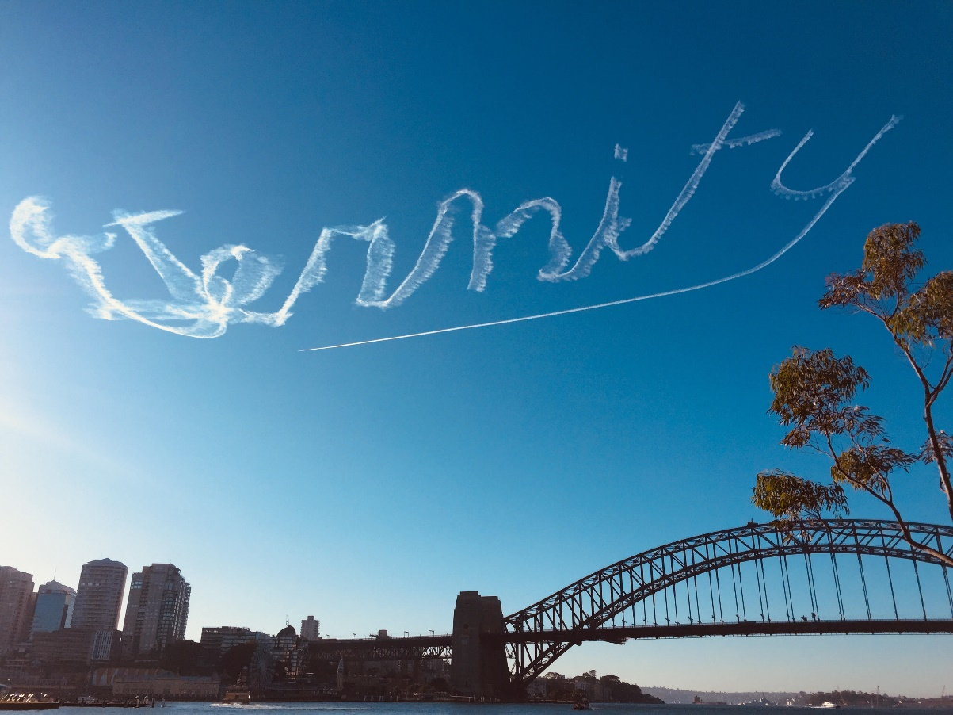

The story of ETERNITY provides a unique perspective on our national identity. This one word features in key moments and at major turning points in Australia's recent history dating back over 85 years ... and is set to continue well into the future.
Link is https://eternityfilm.com.au/about/

