Aboriginal Smoking Ceremony and Its Effects
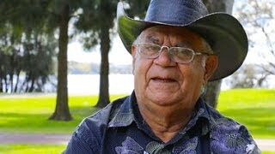
Rodney Rivers, Gosnells, W.A., 13 November 2019
As an indigenous Aboriginal from the Kimberley in NW Australia, it is my duty to alert the public of the dangerous consequences and the curses they will unknowingly put on themselves, their families and others when they are coerced into the promotion and rise of Aboriginal religion. Few people know what the smoking ceremony does. It puts a curse on people, and the results are devastating.
There are two sides to Aboriginal culture: the domestic and the religious. Hunting, cooking, family relationships, etc are part of the domestic side. The religious side involves ceremonies, rituals, spirit and idol worship, witchcraft, astral travelling, ancestral blood covenants, ‘singing’ people with curses to hurt or kill them. Ceremonies and fetishes are used to seduce men or women into wrong relationships. Some men and women even have a relationship with spirit beings. It is also being picked up in astrology by non-Aboriginal people. This all brings people into bondage to the spirit world, because its foundation is animistic. It involves ancestral spirits connected to stones, trees, animals and the natural world. The Aboriginal dreamtime is an evolution of aboriginal myths and stories connected with fear and superstition. I know because I, and thousands of other indigenous people, have come out of that background.
These spiritual forces affect all people, both religious and secular, indigenous and non-indigenous. Aboriginal religion, along with the new-age movement, is part of the smorgasbord of the occult world.
I worked at Argyle Diamond mines for about ten years as an airport worker, then as supervisor in civil works, training officer and safety officer. I served as a mentor to the young indigenous workers at Argyle, and the General Manager consulted with me for advice about mine policy.
Every week when new workers arrive on site they are put through a smoking ceremony and water is sprinkled on them by people from the neighbouring Aboriginal community. It is a ceremony called ‘muntha’ to appease the supernatural generational spirits so they will not harm the workers.
The dreamtime story at the Argyle diamond mine is based on women’s dreaming, known as ‘daiwool’ and a barramundi dreaming story. This smoking ceremony puts a curse on each person who goes through it and causes suicide, and family and marriage breakdown. Many go through divorce – even the last general manager and his wife. It isn’t caused by fly-in/fly-out tensions. Even the marriages of our own Aboriginal people in the area are affected – in communities and towns two hours away from the mine.
Last year a man who worked for Twiggy Forrest’s FMG mine in the Pilbara phoned me to ask if I would come to his house in Perth. He operated a Hyrail computerised vehicle that checks the railway lines for defects. When I arrived at his house I asked what was his problem. He said his daughter was hearing voices, the grandchildren couldn’t sleep at night and a spirit was coming into their house through locked doors. He felt an evil presence and his daughter screamed when she felt it come in. I asked him where was his wife and he said ‘Oh, we divorced’. Then I asked if they had put him through a welcome to country ceremony at the minesite. When he said that they did, I told him that this was the problem, because that smoking ceremony opened the door to a demonic realm. I told him that it gives demons legal access into your life and puts a curse on you that you have brought back to your family. I spent two days at his house removing the curse from his family, house and property and then he felt peace in his home again.
Rio Tinto, BHP and other mining companies, as well as city contractors and developers are using these Aboriginal welcome-to-country smoking ceremonies. They need to realise that they are responsible for the results of these ceremonies, and may be liable to huge pay-outs for compensation. The ceremonies are also rife throughout our nation in every aspect of society.
I need to say that the western mind in general is totally ignorant and has no concept of the supernatural, spirit world and its intervention and influence on everyday life. Modern day psychology, science and medicine totally deny this.
Humanism
What is humanism? Webster’s Dictionary describes humanism as “a doctrine, attitude, or way of life centred on human interest or values. A philosophy that asserts the dignity and work of man and his capacity for self-realisation through reason that rejects supernaturalism.” Humanism is satanic in its origin. Equalitarianism is on the rise in Australia and is a by-product of humanism.
Depression, bipolar, suicidal thoughts, anxiety, mental disorder, psychoses, hallucination, hearing voices, etc are symptoms that come from a spiritual base. There is an important place for doctors and medicine, but there is also a very important place for divine healing. Anti-depressant drugs mask the real issues, which are spiritual. They put a veneer over these problems and hide the real issues. You cannot solve spiritual problems using physical means - it won’t work.
It is no coincidence that a large 750 year old boab tree called Gija Jumulu was transported from Telegraph Creek in the Kimberley to Kings Park in Perth in July 2008. The same people who perform the smoking ceremony at Argyle Mine also performed a smoking ceremony to farewell that tree before its journey south. When the tree arrived at Kings Park, the local Nyoongar people also performed a welcome smoking ceremony. Both of these ceremonies put a curse on this tree. What brought my attention to this tree was a report a few years ago that the tree was dying. As a young man in 1964 I rode on horseback droving cattle past this same tree. When I heard that report, I went up to the tree at night to see why it was dying. While I was thinking about it I saw a plaque just to the left telling the story of the tree and where it came from and the smoking ceremonies that were done to it. I believe that put a death curse on it. So then I had to revoke the curse on that tree. Three months later I found the leaves were back and its life was restored. This was not just a seasonal cycle.
A few months ago a young white man in the Kimberley called me to his house for advice. He and his Philippino wife were having trouble trying to have a baby. His wife asked me to explain a dream she had the night before. I told her that I can’t interpret dreams, but there is a God in Heaven who can. I asked her what the dream was, and she told me about a snake in the dream with two heads. I then told her the interpretation of the dream. In the natural, you don’t see a snake with two heads, but in the spiritual realm the snake represents satan, the devil that brings the curse. “The two heads represent two generational curses of a blood covenant that you don’t know about, made by your ancestors.” Then I spoke to the young man and said that the other head of the snake was a blood covenant made by his ancestors, in Freemasonry or some other ritual that he didn’t know about. These two heads come from blood covenants that have brought a curse that is stopping you from conceiving a child. So I severed off the curse from them. A few weeks ago that young man rang me to say that his wife was pregnant.
The same thing happened with a man married to a woman from South America, and I have had similar requests from people from other countries who have been set free from curses.
Several years ago I was asked by the white matron of a Kimberley hospital to visit a doctor who was having major problems. I said: “Me? Visit a white doctor to help him? It should be the other way around!” She replied: “I think you are the only person who can help him.” When I went to his house, his wife invited me in. As soon as I walked into the house I saw the doctor sitting in the lounge chair with glassy eyes as if he was in a trance. I knew straight away that the problem was that he had been sung using witchcraft to put a curse on him. He was experiencing demons coming up through the floorboards and walls of his house at night. He got the local police to come with a spotlight, but they couldn’t find anything. He was put on sick leave for several months because the doctors said he was insane. It took me two weeks to break the curse that an aboriginal elder was putting on him. He had indigenous artefacts from another country that gave power to this curse. After he got rid of them, he was able to return to work.
I want to tell these stories so that people will know that these curses are real, and the ever-increasing number of smoking ceremonies are having devastating effects on people and the ecological environment.
Aboriginal custom has always used protocols to welcome people to their land, but these smoking ceremonies are spiritual practices to appease the ancestral spirits. When some Aboriginal tour guides take people into traditional places, they speak to the spirits in tribal languages and use rituals to appease the spirits first. Don’t get involved in smoking ceremonies and these rituals. You will open yourself to the power of these curses.
I come from a semi-tribal background where I have observed all these things from when I was a young child. I see the results of these practices and, for around 40 years I have frequently been called upon without any pay or support, to deal with the problems in psychiatric and general hospitals like Graylands, Charles Gardner, Royal Perth, Fiona Stanley and Fremantle Hospitals, and Aboriginal hostels and people’s homes.
Sickness is often a spiritual problem, and I have seen many people released from these sorts of sicknesses. The medical and scientific world often can’t help because they refuse to accept the spiritual basis of the problem presenting before them.
I heard that authorities have banned religion from schools. Aboriginal myths, like the so-called ‘creator’ Rainbow Serpent spirit stories, are being introduced in schools and universities, incorporated into our architecture, painted on buildings and highways, while Christian stories are removed and Christian beliefs are denied and banned. We are beginning to see the devastating results as these spiritual powers are released in our society. May I suggest that we should not discriminate – Aboriginal religion and secular humanism should also be banned.
A young Aboriginal medical student recently asked me why we send students to Christian schools and then to universities to be brain-washed through secular humanism and Aboriginal religion with buildings being ‘smoked’.
Aboriginal people and their communities right across Australia and Torres Strait are beset with psychological issues, people living below 3rd world conditions, and plagued with poverty. These communities are degenerating at a spiralling rate because of this nature-based idolatry, resulting in physical, moral and spiritual decline. This curse must be broken over our people.
In conclusion, I need to say that I don’t speak on behalf of any political, religious, or family group, but only speak from my own heart in my love for this nation.
PS. Several smoking ceremonies have been held in and outside of our Commonwealth Parliament the most recent being the beginning of our 46th Parliament earlier this year. Smoking Ceremony with Raelene Castle head of Rugby Australia The Australian

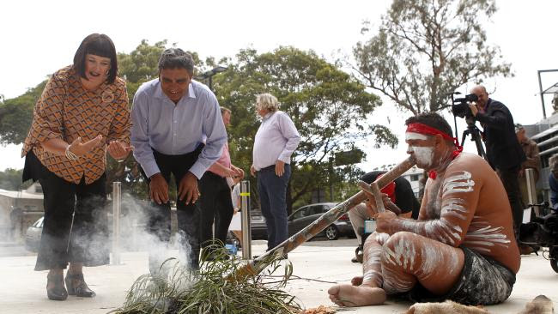

Rodney's Story is told here in Forty Stories.

