**1st Battalion,1 RAR Colours Ceremony in Townsville  - Another Example of our Rich Christian Heritage**

**The 50th anniversary of the** [**Battle of Fire Support Base Coral, Vietnam War**](https://en.wikipedia.org/wiki/Battle_of_Coral%E2%80%93Balmoral) **During Wednesday 16 May and Thursday 17 May 2018, 1st Battalion, The Royal Australian Regiment (1RAR) in conjunction with the 1 RAR Association - INC and the Townsville City Council conducted a series of ceremonial activities to commemorate the 50th anniversary of the Battle of Fire Support Base Coral, Vietnam War.**

**The events were attended by The Governor-General of Australia, His Excellency General the Hon. Sir Peter Cosgrove AK MC (Retd) and Governor of New South Wales His Excellency General the Hon. David Hurley AC DSC (Ret’d)—both of whom are previous Commanding Officers of 1 RAR. Fifty years ago, beginning on 12 May 1968, Australian soldiers fought the Battle of Fire Support Patrol Base (FSPB) Coral. 1RAR, supported by Gunners of the 102nd Field Battery and Armoured Personnel Carriers (APC) from A Squadron, 3rd Cavalry Regiment, held their ground and achieved their mission against all odds.**

**Over five days 19 Australians were killed and 47 wounded in the action more than in the** [**Battle of Long Tan**](https://en.wikipedia.org/wiki/Battle_of_Long_Tan) **in August 1966.**

**In recognition of the bravery demonstrated by those who fought at FSPB Coral, the Battalion was awarded the Battle Honour ‘Coral Balmoral’. This Honour endures, emblazoned on the Battalion’s Regimental Colour**

**When the Parade was repositioned and all appropriate personnel were in place, the CO Lt Col Benjamin McLennan commenced the Service by saying:  
  
‘Soldiers have always made for themselves signs and emblems which are a mark of their loyalty to their rules, and of the duty to honour the laws of the community in which they are placed by God. So, following this custom, we come together before God to ask His blessing on these Colours, which are to represent to us our duty towards our Sovereign and our Country. May these Colours be a sign to all of us that God is with us always, in all dangers and difficulties. May they increase our faith and hope in him who is King of Kings and Lord of Lords.’**

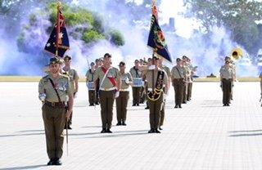

**The CO Lt Col Benjamin McLennan and those on Parade then said the following:  
  
CO: To the honour and service of God.  
All: We dedicate ourselves.  
CO: To the honour of our Sovereign, to the love of our Country and to the good of all people.  
All: We dedicate ourselves.  
CO: To uphold the honour and sacredness of our promises.  
All: We dedicate ourselves.  
CO: To the protection of all travellers.  
All: We dedicate ourselves.  
CO: To the preservation of order and good government.  
All: We dedicate ourselves.  
CO: To the sacred memory of our comrades, whose courage and endurance have given us the freedom we enjoy and the heritage we must preserve.  
All: We dedicate our Colours.  
CO: Mindful of these solemn promises and our resolve to keep them.  
All: We dedicate our Colours.**

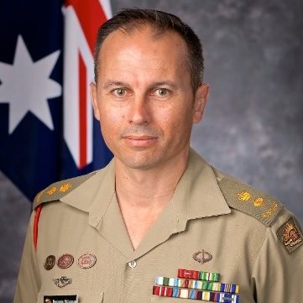

**The CO  Lt Col  Benjamin McLennan (pictured. Son of Tony McLennan) ordered the Parade to attention saying.**

**‘Reverend Sirs, on behalf of the Regiment we ask you to bid God’s blessing on these Colours.’  
  
Each Principle Chaplain on the Parade moved forward in turn to consecrate, bless or dedicate the Colours.  
  
The Principle Chaplain Anglican, placing his hands above the Colours, said:  
  
‘We consecrate and set apart these Colours as a perpetual sign of God’s presence and our duty to the Sovereign and Country, and an inspiration to all who follow them. In the name of the Father, and the Son, and the Holy Spirit. Amen.’  
  
The Principle Chaplain Roman Catholic, placing his hands above the Colours, said:  
  
‘Bless, O Lord, these Colours, which we bless in Your Name, that those who follow them, may be ever mindful of Your Presence, guided by Your Will, and guarded by Your Providence. In the name of the Father, and the Son, and the Holy Spirit. Amen.’  
  
The Colours were then sprinkled with Holy Water.  
  
The Principle Chaplain Protestant Denominations, placing his hands above the Colours, said:  
  
‘In the name of the Father and the Son and the Holy Spirit, we do dedicate and set apart these Colours, that they may be a sign of our duty towards our Sovereign and our Country in the sight of God. Amen.’  
  
The CO  Lt Col Benjamin McLennan stood the Parade at Ease and said, with all those on Parade:  
  
‘Almighty God, who has called us to be citizens of Australia, enable us to walk worthy of our calling. Unite us all in true Christian love with one another. Help us to fulfill the duties which may be laid upon us. Keep us calm, steadfast and unselfish. Grant that at all times we may place our whole trust and confidence in your mercy and always live by your commandments, through Jesus Christ our Lord. Amen.’  
  
The CO Lt Col Benjamin McLennan and all those on Parade, said the Lord’s Prayer.** [Watch video here.](https://youtu.be/74CXP2O8aNs)

**Following presentation of the new Colours by His Excellency, the Governor General, the CO Lt Col Ben McLennan said:  
  
‘With proud thanksgiving we farewell our Old Colours, and the citations that caress them; under which over 10,000 men and women, amongst this nation’s finest, some of whom are here with us today, served, and fought, with distinction.  
  
With pride, inspiration and grace, we humbly receive our New Colours and citations. We, and those who follow us, will go where they are called by our nation, without question, without counting, without complaint.  
  
We will cherish and honour these New Colours as the embodiment of our Battalion’s soul, our Army’s values and our nation’s trust.’**

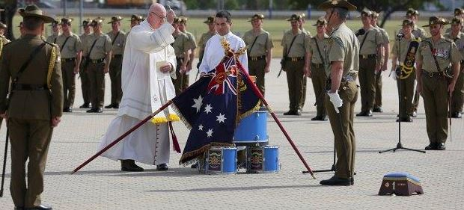

Follow this link to see another video:

<https://www.facebook.com/AustralianArmy/videos/10156049439366195/>