**By Ps Barbara Miller**[**http://barbara-miller-books.com/**](http://barbara-miller-books.com/)

**William Cooper was an Aboriginal Australian Christian who lived from 1860-1941. He was a Yorta Yorta man born near Echuca in the Murray River area. He was one of the first Aboriginal people in Australia to accept Christianity following the lead of his brothers and sisters. Daniel and Janet Mathews set up Maloga Mission distressed at the treatment of Aboriginal people and William learned to read and write very quickly. Daniel also encouraged the Aborigines to follow his steps in actively working to improve the situation of Aboriginal people, sending petitions to government etc.**

**William Cooper’s legacy persists today in the yearly celebration of NAIDOC or National Aboriginal and Islander Day Observance Committee which is celebrated in July. He is the father of NAIDOC. William spent many years working for the “uplift” as he called it of his people, writing letters to federal and state governments and newspapers, meeting Prime Minister Lyons and other MPs and petitioning the King of England.**

**However, the Australian government would not forward his petition to the King because Aborigines were not citizens of Australia, having lost that status at federation. Disillusioned, Cooper set up two things. One was the Day of Mourning for the 150th anniversary of European settlement in Sydney which he organised with NSW leaders such as Bill Ferguson, a Presbyterian Aboriginal and Jack Patten. They felt they could not celebrate the occasion.**

**The other was Aboriginal Sunday where Cooper persuaded the National Missionary Council to set aside the first Sunday before Australia Day to pray for and teach about the Aboriginal situation. The first was in 1940 and it gradually changed to a secular as well as a church event, became week-long and included Torres Strait Islanders.**

**Cooper set up one of the first Aboriginal organisations in Australia – the Aborigines Advancement League which did welfare work and helped the Cummeragunja Aborigines on strike because of the bad conditions they lived under. He set a platform for and mentored the next generation of leaders like his nephew, Sir Pastor Doug Nicholls who became the only Aboriginal governor of an Australian State – South Australia.**

**Cooper is fondly remembered by the Jewish community of Australia and has been honoured by Yad Vashem Holocaust Memorial Centre in Jerusalem because he led the only known private protest worldwide against Kristallnacht, the start of the Holocaust in 1938. He has an Academic Chair of Resistance to the Holocaust named after him. This was touching because he was not a citizen or counted in the census of his own country. He mentored some of the leaders who worked for the 1967 referendum to have Indigenous people counted as people not flora and fauna (plants and animals) in Australia’s constitution.**

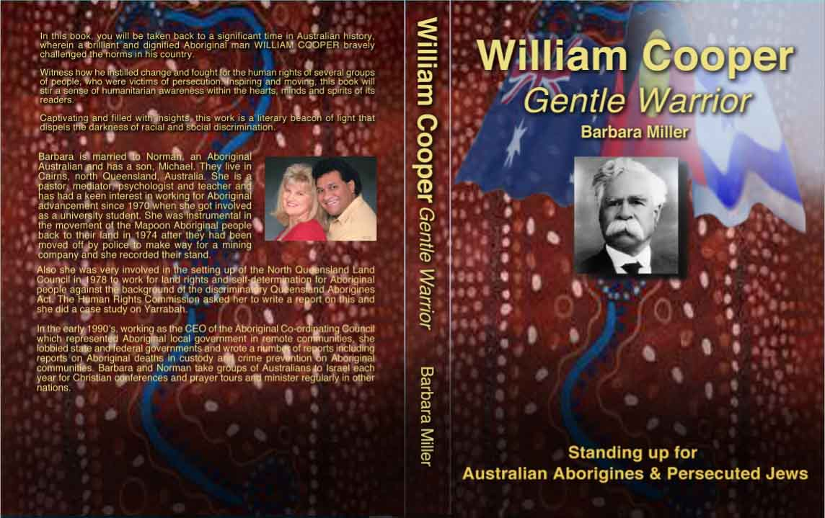

**My book “William Cooper, Gentle Warrior: Standing Up for Australian Aborigines and Persecuted Jews” brings to life this man of good Christian character, humility, integrity, vision, perseverance and charm. He had a commitment to God and social justice and was inspired by stories of the Jewish people coming out of captivity into the Promised Land and inspired by Negro spirituals that Mathews sang. The book is also a history of Aboriginal- European contact from settlement till today. Copies available from** [**http://barbara-miller-books.com/**](http://barbara-miller-books.com/)